AN INTER-DISCIPLINARY AND MULTI-SCALE APPROACH TO ASSESS THE SPATIAL VARIABILITY OF GROUND MOTION FOR MICROZONATION PURPOSES: THE CASE STUDY OF CAVEZZO MUNICIPALITY IN THE PO PLAIN (ITALY)

Lai^{1,2} C.G., Bozzoni² F.*, Zuccolo¹ E., Famà¹ A., Poggi³ V., Massa⁶ M., Mascandola C., Petronio L., Conca¹ D., Özcebe¹ A.G., Meisina⁴ C., Bonì⁴ R., Martelli⁵ L., Cosentini⁷ R.M.

¹Department of Civil and Architectural Engineering, University of Pavia, Italy
²European Centre for Training and Research in Earthquake Engineering, EUCENTRE, Pavia, Italy
³Italian Institute of Experimental Oceanography and Geophysics, OGS, Trieste, Italy
⁴Department of Earth and Environmental Sciences, University of Pavia, Italy
⁵Regione Emilia-Romagna, Bologna, Italy
⁶Italian Institute of Geophysics and Volcanology, INGV, Milano, Italy
⁷Department of Structural, Building and Geotechnical Engineering, Politecnico di Torino, Italy
*Corresponding author: Francesca Bozzoni, Researcher, European Centre for Training & Research in Earthquake Engineering, Via Ferrata, 27100 - Pavia, Italy, francesca.bozzoni@eucentre.it

ABSTRACT

In July 2017, an inter-institutional agreement was signed between the University of Pavia, Eucentre, the administration of Emilia-Romagna Region, the Province of Modena and the Municipality of Cavezzo to perform a microzonation study at the town of Cavezzo (Modena, Northern Italy). This research study was led as part of the European H2020 project LIQUEFACT, initiated in May 2016 with the main goal of establishing guidelines for the assessment and mitigation of damages to structures and infrastructures caused by earthquake-induced soil liquefaction. Within this framework, the municipality of Cavezzo was selected, among four European testbed territories, as case-study for mapping the liquefaction hazard at urban scale that is for preparing a microzonation chart.
In this paper we discuss the work carried out in Cavezzo to characterize the spatial variability of ground motion amplification due to local ground conditions. A multi-disciplinary approach is presented, involving geotechnical engineers, geophysicists, geologists and seismologists from different institutions with the goal of thoroughly characterizing the territory at different scales and different level of confidence. Geomorphological, geological, hydrogeological, seismological, geotechnical and geophysical investigations were carried, with a special focus on the mapping and propagation of uncertainties. A GIS-based (Geographic Information System) platform was setup to manage the collected data, which now includes the results of more than 1,000 geotechnical and geophysical tests. Such extended dataset allowed the definition of a comprehensive geotechnical and a seismo-stratigraphic model of the territory, used as input for linear-equivalent ground response analyses.

- INTRODUCTION

The Seismic Microzonation (SM) is the process that aims at identifying and mapping the subsoil seismic response and earthquake-induced phenomena of a given territory (typically an urban area) at local scale. This is done in terms of both selected ground shaking intensity parameters and susceptibility to ground instabilities. In Italy, guidelines for seismic microzonation were issued by Emilia-Romagna region in 2015 (DGR n.2193) to support territorial and urban planning. These guidelines establish criteria and operational instructions for the identification of areas subject to local seismic effects in order to guide planning towards areas characterized by lower seismic hazard. Three levels of investigation are identified.
Level 1 is the preparatory level for the SM studies and aims at identifying major areas susceptible of site effects (i.e. ground motion amplification, slope instability, soil liquefaction, ground fractures, etc.); it mostly relies on the collection of existing data, which are processed to divide the investigated area into zones that are qualitatively homogeneous in a seismic perspective. Level 2 defines site effects with a quantitative evaluation of seismic amplification factors using geophysical information and ad-hoc amplification’s tables (abacus), usually in PGA and spectral intensities. Level 3 is the most detailed and it requires focused in-situ investigations and numerical ground response analysis, for a better and more quantitative identification of potential seismic hazard. Whereas level 1 and 2 studies are nowadays fairly common, a level 3 analysis is generally restricted to few cases of special interest, given the considerable investment required in term of time and resources. In several cases, however, level 3 microzonation studies are performed using not adequate methodological approaches and over-simplified assumptions, leading to large uncertainties, often not properly quantified and documented.
One of the main goals of the H2020 European project LIQUEFACT (http://www.liquefact.eu/) is the definition of objective criteria to assess liquefaction hazard at different geographical scales. The project, initiated in May 2016 and that will end in October 2019, also aims at addressing other risk-related aspects of liquefaction potential, including the assessment and mitigation of damages to structures and infrastructures caused by earthquake-induced soil liquefaction. LIQUEFACT work Package 2, led by University of Pavia in collaboration with Eucentre, deals with the problem of performing zonation of the territory, from continental to sub-municipal scale. In this framework, four European testbed territories were selected as optimal benchmarks, in order to perform seismic microzonation for earthquake-induced liquefaction hazard assessment. Target areas are located in Emilia-Romagna region (Northern Italy), Lisbon metropolitan area (Portugal), Ljubljana area (Slovenia) and in Marmara region (Turkey), within areas known to have experienced liquefaction effects during past earthquake events. With reference to the Italian case study, an inter-institutional agreement was signed in July 2017 involving the University of Pavia, Eucentre, the administration of Emilia-Romagna Region, the administration of the Province of Modena to perform a level 3 microzonation of the municipality of Cavezzo (Modena, Italy), with a special focus on the definition of the liquefaction potential of the area.
In this paper we present a summary of the work done for the seismic microzonation of Cavezzo. In particular, it will be discussed the creation of a comprehensive site-response model obtained from joint analysis of existing available data and new ad-hoc geotechnical/geophysical investigations. Special attention was given to the treatment and propagation of the uncertainties, accounted both in term of overall variability of the input information and the related data processing and modeling assumptions. The interdisciplinary nature of the work done is here strongly highlighted, discussing the diversity of calibration data and methodological approaches and the way these have been collectively handled to create a unique but comprehensive ground motion amplification model.

- GEOLOGICAL AND SEISMOTECTONIC SETTING

The Cavezzo municipality is located within the northern sector of the Modena province (Italy), on the right side of the Secchia River. The study area sits within the western margin of the Po plain, a large foreland sedimentary basin originated by the progressive convergence of the Africa/Adria and Eurasia plates initiated during the late Cretaceous and still ongoing. Such compressional regime led to the development of large thrust and folds structures with roughly WNW-ESE trending, but of opposing vergence to the North and to the South of the longitudinal valley axis. Some of the southern buried structures have demonstrated to be still under active shortening, causing non-negligible past seismicity, whose noticeable expression was the recent 2012 Emilia sequence.
The sedimentary infill of the Po plain consists of a thick sequence of sediments of Tertiary-Quatertiary age, from fine Pliocene muds to more course silt, sand and gravel alternations due to transition to continental deposition from the Pleistocene. Depositional sequence is heavily disturbed by the ongoing deformation process and the alternation of episodes of erosion and glaciation, which have generated several noticeable angular unconformities and gaps (Mascandola et al. 2019).
At local scale, Cavezzo is on the southern limb of the buried Mirandola antiform (Boccaletti et al., 2004; Martelli et al., 2017). The lithostratigrafic succession of the area is composed by alluvial deposits ranging in thickness from around 130 m in the northern area to 280 m in the southern one (RER-ENI, 1998). The bedrock is constituted by interbedded marls and sands of the Pliocene and Lower Pleistocene “Argille Azzurre” Formation and Middle Pleistocene “Imola Sands” Formation (RER-ENI, 1998). The alluvial deposits in the Cavezzo area are characterized by interbedded fine silty-clayey soils with layers rich of peat and interbedded sands and silty sands. These surficial sediments were deposited by the Secchia River, whereas the deeper sand layers were deposited by the Po River (Castaldini, 1989).
From the morphological point of view, the study area is located in the alluvial plain of the Secchia River, ranging in elevation from 34 m a.s.l. in the southern and western sector to around 20 m a.s.l. in the northern part. It is worth noting that the highest topographic level is reached in correspondence of the modern artificial levees of the Secchia River, which raise about 7-8 m above the surrounding area (Figure 1). The study area includes different geomorphological features interpreted as floodplain, fluvial ridges and crevasse splays. The subsoil of Cavezzo is mainly characterized by silty-clayey sequences including channel-filling and crevasse splay sand layers (Pellegrini and Zavatti, 1980).

- METHODOLOGY

Starting from the creation of a comprehensive GIS database of available measurements, a lithological model was first constructed from the analysis of boreholes and CPT results. From that, homogeneous areas identifying the major lithological units (LU) were outlined. Next, stratigraphic vertical cross sections were developed oriented longitudinally and transversally with respect to the main geomorphological features. A 3D geological model was then constructed for the territory under study down to a depth of 30 m and for an area of approximately 27 km².
In a following step, a large-scale seismo-stratigraphic pseudo-3D model was developed based on new data acquired from the geophysical surveys. At this purpose, advance geophysical processing techniques were used, such as the combined inversion of multi-component surface wave datasets based on a joint interpretation of travel-time, dispersion and polarization data. This has led to the definition of different realizations of 1D seismo-stratigraphic profiles at each of the 2,984 nodes of a grid with a 0.001 degrees spatial resolution (about 100 meters) covering the Cavezzo territory. Overall, 11 complementary seismo-stratigraphic models were defined at each node. The resulting 3D model has then been used for the calculation of the seismic amplification factors through ground response analyses, considering the epistemic uncertainty associated to the input models.
More specifically, at each of the 2,984 nodes and for each of the 11 seismo-stratigraphic models, 1D ground response analyses were carried out using the linear-equivalent soil constitutive model. The input motions referred to outcropping bedrock conditions were defined for 475, 975, and 2,475 years return periods in terms of suites of 7 seismo- and spectrum-compatible real accelerograms. For each return period, 229,768 analyses were carried out considering 2,984 nodes, the 11 seismo-stratigraphic models and the 7 accelerograms. Results have been finally combined in a logic-tree approach to better depict the epistemic variability in the ground motion amplification associated to the uncertainties in the definition of the 3D seismo-stratigraphic model and the variability of reference input motion.

- DATABASE OF GROUND CHARACTERIZATION

To carry out ground response analyses, an accurate knowledge of the geotechnical characteristics of the shallow subsoil of the site is required. For this purpose, the territory of Cavezzo was thoroughly characterized from different viewpoints, i.e. geomorphological, geological, hydrogeological, seismological, geotechnical and geophysical.
As starting point, existing data retrieved from trench pits, boreholes, piezometric, in situ and laboratory geotechnical and geophysical investigation campaigns were collected. Figure 2a shows the existing data available for ground characterization of the territory of Cavezzo before the LIQUEFACT project started. Based on the quality and quantity of the retrieved existing data, then, complementary ground investigation campaigns were purposely devised (Figure 2b).
In-situ ground investigation included cone penetration tests with acquisition of the excess pore pressure (CPTu) and the shear wave velocity Vs (SCPTu), standard penetration tests (SPT) and the drilling of boreholes. Laboratory tests were also performed on undisturbed samples retrieved with the gel-push technique (Cubrinovski et al., 2016). Furthermore, a number of non-invasive geophysical tests were performed, including 3D electric tomography and multi-channel analysis of surface waves (MASW). Fundamental was the contribution of the National Institute of Geophysics and Volcanology (INGV Milano) and the National Institute of Oceanography and Applied Geophysics (OGS, Trieste), who respectively led a large-scale ambient vibration survey (including single-station and 2D array measurements) and a high-resolution P/S reflection seismic acquisition campaign. Such combined geophysical prospecting allowed illuminating large volumes of soils, while providing a mean to correlate the results obtained at different locations from the conventional geotechnical tests.
All data gathered on the subsoil of Cavezzo were organized into a purposely-developed GIS database, which now includes the results of more than 1,000 geotechnical and geophysical tests, as shown in Figure 2b. Data of both 1m and 5m resolution DEM were also included.

- SOIL MODEL IMPLEMENTATION

  - Surface geotechnical/lithological model

Based on joint analysis of stratigraphic, lithological and geomorphological information, the municipality of Cavezzo was tentatively divided in geologically homogenous areas. As starting point, 9 main geological domains have been identified based on joint stratigraphic analysis of boreholes and water well and from interpretation of CPTu/CPT tests. These domains were used to separate zones of supposedly homogeneous lithological and genetic depositional characteristics (Figure 2). For the stratigraphic interpretation from CPTu/CPT data it was used a correction of Soil Behaviour Index (Ic, Robertson 2009) calibrated based on CPTu tests and boreholes (Meisina et al 2019) in order to identify the mixture layers falling within the transition zone of reference chart (Robertson, 2009).

  - The seismo-stratigraphic model

A seismo-stratigraphic soil model was subsequently implemented by integrating information from a variety of data, including the results from the processing of active and passive seismic data, either already available from previous studies (mostly MASW) and from ad-hoc seismic investigations. Assuming a relatively smooth variability of the geophysical properties of the soil across the area, a pseudo-3D model was implemented starting from a set of velocity models obtained from a single target site, chosen as sufficiently representative (on average) of the investigated region (see Figure 2).
Two main families of velocity models were obtained by combining the results from the inversion of surface wave dispersion information from three-component array analysis (Poggi et al. 2010) of ambient vibrations (hereinafter the EUCENTRE model) and from the processing of reflection P/S seismic data (OGS model), for a total of 11 independent profiles. The two seismic techniques have shown to produce consistent results down to about 100m depth, while some deviations were observed at larger depths. Such discrepancy has been considered as epistemic variability of the reference velocity models, and accounted in the following processing by means of a logic-tree approach.

  - Mapping surface variability over the area

In a subsequent step, for each point of the pseudo-3D model the reference profiles have been adjusted to match the observed variability of both the shallow subsoil conditions and of the deepest resonating layer interface (assumed to be the local geophysical bedrock). For that, a map of the surface velocity variability was first obtained by interpolation of Vs30 estimates from 83 previous MASW analysis (Figure 5). It must be noted that being the results from MASW data quite heterogenous (e.g. obtained from different surveys and using different processing schemes), we decided to homogenously reassess the Vs30 of each measurement by means of a simplified procedure as proposed by Brown et al. 2000 and further developed by Martin & Diehl 2004 and Albarello & Gargani 2010 (see also Comina et al. 2011 for clarifications). In practice, the Vs30 of a site was obtained empirically from the Rayleigh wave dispersion curve by extracting the phase velocity corresponding to a wavelength (λ) in a range between 35 and 45 m. In this study we used a λ of 40m, which provided estimates of Vs30 comparable with those obtained from independent processing. Spatial interpolation of the Vs30 values was performed using Ordinary Kriging, providing for each point of the interpolated grid a mean velocity value and the corresponding expected uncertainty. Finally, at each location, the reference velocity profiles have been adjusted to honour the identified local Vs30 value. The adjustment is simply performed by applying a depth dependent correction factor, whose effects is progressively decreasing (following a negative exponential factor) at increasing depth. This insure that the observed shallow variability does not sensibly impact the seismic model at large depths.

  - Seismic bedrock constraints

Complementary, the geophysical bedrock was obtained by inversion of the fundamental frequency of resonance (f0) obtained from horizontal to vertical ratio analysis (e.g. Nogoshi & Igarashi 1971; Nakamura 1989; Haghshenas et al. 2008) of 26 single station ambient vibration measurements performed on the area. For the inversion, we used the procedure proposed by Poggi et al. (2012) based on Rayleigh wave ellipticity peak matching. Consistently with the procedure used to map shallow velocity variability, spatial interpolation between inverted bedrock depths was finally performed using Ordinary Kriging, with an estimate of the related uncertainty.

  - The final seismic-geotechnical model

The final seismic-geotechnical model was defined starting from pseudo-3D seismo-stratigraphic model, consisting of 10 realizations from the EUCENTRE profile, each with an associated a weight of 0.05, and a profile from reflection seismic (OGS), which was associated a larger weight of 0.5. Each independent 3D model consists of 2984 monodimensional (1D) Vs-profiles, located on a reference grid that covers the territory of Cavezzo municipality. Therefore, a total of 32824 profiles (2984x11) have been defined and used for the analysis. In order to perform ground response analysis, a unique seismo-geotechnical model was created by merging the properties of the geological/lithological and the geophysical models. The 9 the geologically homogeneous areas discussed in {3.2} were used considering the uncertainty associated. For each homogeneous area, the points of the reference grid falling within its boundaries have been identify and for each layer of 11 geophysics models, a statistical analysis of thickness values was performed [NON CAPISCO]
Since the assessment of local stratigraphic site effects was performed by 1D linear-equivalent analysis using SHAKE91 code, an ad-hoc calibration of the shear modulus and damping ratio decaying curves was accomplished following the methodology proposed by Darendeli (2001) and using data from laboratory tests performed in December 2017 in Southern portion of the study area.

- SEISMIC RESPONSE FOR MICROZONATION

  - Definition of the reference seismic input and its variability

The guidelines for SM (DGR n.2193) provides three signals to be used as input motion for local ground response analyses. However, these signals are not independent of each other and are referred only to the 475 years return period. Therefore, the seismic hazard at the site under examination was redefined, for the three considered return periods (475, 975 and 2475 years), in terms of elastic acceleration response spectra referred to rigid ground conditions, and seismo- and spectrum- compatible natural accelerograms.
The elastic response spectra were computed according with the prescriptions of the previous Italian seismic code (NTC, 2008). Table 1 summarizes, for each considered return periods, the values of the parameters necessary to define the elastic response spectra for soil class A with reference to the Municipality of Cavezzo: ag is the horizontal peak ground acceleration on a horizontal rigid reference site, F0 is the maximum value of the amplification factor of the horizontal acceleration spectrum and TC* is the upper limit of the period of the constant spectral acceleration branch.
For each return period, a group of 7 independent accelerograms recorded on free-field rock ground conditions, spectrum-compatible with the elastic response spectrum defined by the NTC (2008) for the municipal territory of Cavezzo was selected. The selection was made using an updated version of the program ASCONA (Corigliano et al., 2012), which provides a set of strong motion recordings satisfying several criteria (e.g., magnitude and distance ranges, spectral shape), with the additional requirement of compatibility with a target spectrum (in this case, the elastic acceleration response spectrum prescribed by the Italian code in force), in a specified period interval (in this case, from 0.15 s to 2 s). Regarding signal scaling, the PEER (2010a, 2010b) approach was used. Among the different accelerogram sets that satisfy the requirements, the set returned by ASCONA is the one characterized by the minimum average deviation of the average response spectrum (of the 7 accelerograms) with respect to the target spectrum.

  - Ground response analysis

One-dimensional local seismic response analyses were carried out for Cavezzo using the SHAKE91 code (Schnabel et al., 1972; Idriss and Sun, 1992). The analyses were conducted for 3 return periods, 7 accelerograms, 2,984 points of the reference grid for which the geotechnical-seismic model P3D was defined and 11 models, for a total of 229,768 analyses. For each analysis, amplification factors (Fi) in terms of peak ground acceleration, Housner intensity ratio (computed for four different period intervals) and acceleration response spectrum integral ratio computed in the spectral interval between 0.1s and 0.5s were computed. For each node of the grid and each return period, the Fi values computed from the 7 accelerograms and 11 models were averaged as follows:

(1)
where w_accj is the weigth of the accelerogram, assumed to be the same for all accelerograms (w_accj=1/7), w_modk is the weigth of the P3D model (w_modk=0.05 for each of the 10 models based on INGV data and w_modk=0.5 for the OGS model), while Fijk is the amplification factor Fi associated with the j-th accelerogram and the k-th P3D model.
Note that the suitability of the 1D modelling in Cavezzo, mostly characterized by flat parallel layers with a negligible slope of the substrate roof (around 5% in its steepest part), was confirmed by a 2D site response analysis performed with the code QUAD4M (Hudson et al., 1994). In fact, the 2D analysis, which was performed with reference to a 110 m – long section crossing the municipality along the NS direction (i.e. the one with the largest variability in the subsoil stratigraphy), allowed to obtain amplification factors similar to those obtained by the 1D analysis.

- RESULTS

Figure 6 shows the map of the amplification factors computed for the municipality of Cavezzo considering the 475 years-return period. The amplification factors (Fi) are showed in terms of peak ground acceleration FPGA expressed as PGA/PGA0 (Top-left) and Housner intensity ratio expressed as SI/SI0 and computed for three different period intervals: FH0.1-0.5s (Top right), FH0.5s-1.0s (Bottom left), FH0.5-1.5 (Bottom right). The terms PGA0 and SI0 are respectively the peak ground acceleration and Housner intensity related to the reference input motion. The largest amplification factors are expected in the northern part of the municipality, in the proximity of the culmination of the Mirandola anticline, it is clearly visible in four maps. Moreover, it is interesting to note that this map clearly reflects the homogeneous areas defined based on lithological and genetic depositional environment. The boundaries of these areas can be clearly seen in trend of values of amplification factors; as example for the high period range, namely FH0.5s-1.0s (Bottom left), FH0.5-1.5 (Bottom right) lower values were obtained in particular areas in the Western part of the municipality.

- DISCUSSION AND CONCLUSIONS

…
From the final amplification results it is evident how the different contributions to the creation of the seismic-geotechnical model have a significant impact on the spatial variability of the surface ground motion. This clearly highlights the importance of merging information different methodological approaches and from different resolution scales in an interdisciplinary framework.
…
It must be noted that the presented procedure strictly applies on those cases of known smooth variation of the subsoil properties over the area, as the simplified assumption of one-dimensionality is locally applied at each point of the calculation grid. In case of evident 2D/3D response, the use of more sophisticated numerical analysis is unavoidable. Nonetheless, such condition must be evaluated carefully case by case, e.g. by preliminary inspection of the H/V spectral ratio variability across the area, in order to justify the increased investment required for such specialized analysis. So far, very few attempt are available in literature to objectively quantify the possibility of morphological effects, which makes this aspect an open field of research.
…
It is important to note that a linear equivalent approach was used to carry out ground response analysis. This approach using a viscoelastic constitutive model for the soil and is not reliable to reproduce the seismic response of a soil deposits exhibiting strong nonlinear behaviour. In these situations, fully nonlinear ground response analyses are recommended. These allow to reproduce complex hydromechanical phenomena like dynamic consolidation, cyclic-mobility and liquefaction coupled with ground response. However, they require the adoption of advanced constitutive models based on critical state soil mechanics and incremental poro-elasto-plasticity. These models encompass a large number of geotechnical properties and parameters whose definition requires an extensive site-specific, geotechnical characterization involving numerous and sophisticated field and laboratory tests.
…
As a following development, we envisage a full integration of the quantified uncertainties for each soil parameters (e.g. observed shallow velocity variability), for instance by performing stochastic sampling, which in our opinion would likely allow a more robust and defendable estimate of the expected amplification factors.

ACKNOWLEDGMENTS

This research has been carried out within the framework of the European LIQUEFACT project. The LIQUEFACT project has received funding from the European Union’s Horizon 2020 Research and Innovation Programme under Grant Agreement No. 700748. This support is gratefully acknowledged by the authors.

REFERENCES

Boccaletti, M., Bonini, M., Corti, G., Gasperini, P., Martelli, L., Piccardi, L., Severi, P. & Vannucci, G. 2004: Carta sismotettonica della Regione Emilia-Romagna, scala 1:250.000. Note illustrative. Regione Emilia-Romagna–SGSS, CNR-IGG. SELCA, Firenze.
Castaldini, D. 1989. Evoluzione della rete idrografica centropadana in epoca protostorica e storica. Atti Conv. Naz. Studi "Insediamenti e viabilità nell'alto ferrarese dall'Età Romana al Medioevo". Cento 8-9 May 1987 Acc. delle Sc. di Ferrara, 115-134, Ferrara.
Corigliano, M., Lai, C.G., Rota, M., Strobbia, C.L. (2012). “ASCONA: automated selection of compatible natural accelerograms”. Earthquake Spectra, 28(3): 965-987.
Cubrinovski, M., Stringer, M., Haycock, I. (2016). Experience with gel‐push sampling in New Zealand. http://www.nzgs.org.
Haghshenas, E., Bard, P.-Y., Theodulidis, N. & SESAME WP04 Team, 2008. Empirical evaluation of microtremor H/V spectral ratio, Bull. Earthq. Eng., 6(1), 75–108.
Hudson, M.B., Beikae, M., Idriss, I.M. (1994). “QUAD4M, a Computer Program to Evaluate the Seismic Response of Soil Structures Using Finite Element Procedures and Incorporating a Compliant Base Center for Geotechnical Modeling”, Department of Civil and Environmental Engineering, University of California, Davis.
Idriss, J., Sun, J.I. (1992). SHAKE91 - a computer program for conducting equivalent linear seismic response analyses of horizontally layered soil deposits. University of California, Davis, USA.
Lai, C.G., Meisina, C., Bozzoni, F., Conca, D., Famà, Özcebe, A.G., Zuccolo, E., Bonì, R., Poggi, V., Cosentini, R.M. (2019). Mapping the liquefaction hazard at different geographical scales. Proceedings 7th International Conference on Earthquake Geotechnical Engineering, 7ICEGE, Rome, Italy, 17-20 June, 2019.
Lo Presti, D., Sassu, M., Luzi, L., Pacor, F., Castaldini, D., Tosatti, G., Meisina, C., Zizioli, D., Zucca, F., Rossi, G., Saccorotti, G., & Piccinini, D. 2013. A Report on the 2012 Seismic Sequence in Emilia (Northern Italy). International Conference on Case Histories in Geotechnical Engineering. 3.
Lugli S., Marchetti Dori S., Fontana D. 2007. Alluvial sand composition as a tool to unravel the Late Quaternary sedimentation of the Modena Plain, northern Italy. In: Arribas, J., Critelli, S., Johnsson, M.J. (Eds.), Sedimentary Provenance and Petrogenesis: Perspectives from Petrography and Geochemistry. Geological Society of America Special Paper, 420, 57-72.
Martelli, L., Bonini, M., Calabrese, L., Corti, G., Ercolessi, G., Molinari, F. C., Piccardi, L., Pondrelli, S., Sani, F. & Severi, P. 2017. Carta sismotettonica della Regione Emilia-Romagna e aree limitrofe. Note illustrative. Regione Emilia-Romagna, Servizio geologico, sismico e dei suoli. D.R.E.AM. Italia.
Meisina, C., Bonì, R., Bordoni, M., Lai, C.G., Bozzoni, F. et al. 2019. 3D Geological model reconstruction for liquefaction hazard assessment in the Po Plain. Proceedings 7th International Conference on Earthquake Geotechnical Engineering, 7ICEGE, Rome, Italy, 17-20 June, 2019
Nakamura, Y., 1989. A method for dynamic characteristics estimation of subsurface using microtremor on the ground surface, Quart. Records Railway Tech. Res. Inst., 30, 25–33.
Nogoshi, M. & Igarashi, T., 1971. On the amplitude characteristics of microtremor, Part II, J. seism. Soc. Japan, 24, 26–40.
NTC (2008). Norme Tecniche per le Costruzioni. Decreto del Ministero delle Infrastrutture del 14 gennaio 2008. Gazzetta Ufficiale, n. 29 del 4 febbraio 2008, Supplemento Ordinario n. 30, www.cslp.it, Istituto Poligrafico e Zecca dello Stato, Roma (in Italian).
NTC (2018). Norme tecniche per le costruzioni. Ministero delle Infrastrutture e dei Trasporti, Decreto Ministeriale del 17 gennaio 2018, Supplemento ordinario alla G.U. n. 8 del 20 febbraio 2018 (in Italian)
PEER (2010a). Technical report for the PEER ground motion database web application-Beta Version-October 1, 2010. Pacific Earthquake Engineering Research Center (PEER).
PEER (2010b). User’s Manual for the PEER ground motion database web application-Beta Version-October 1, 2010. Pacific Earthquake Engineering Research Center (PEER).
Pellegrini, M. & Zavatti, A. 1980. Il sistema acquifero sotterraneo tra i fiumi Enza, Panaro e Po: alimentazione delle falde e scambi tra falde, correlazioni idrochimiche”. Quaderni IRSA, 51(1), Roma.
Poggi, V. and Fäh, D., 2010. Estimating Rayleigh wave particle motion from three-component array analysis of ambient vibrations. Geophys. J. Int., Volume 180, Issue 1, 251-267.
Poggi, V., Fäh, D., Burjánek, J. and Giardini, D., 2012. The use of Rayleigh wave ellipticity for site-specific hazard assessment and microzonation. An application to the city of Luzern (Switzerland). Geophys. J. Int., Volume 188, Issue 3, 1154-1172.
RER–ENI. 1998. Riserve idriche sotterranee della Regione Emilia-Romagna. G. M. Di Dio. Regione Emilia- Romagna, ENI Agip Divisione Esplorazione e Produzione. S.EL.CA., Firenze, pp 120.
Schnabel, P.B., Lysmer, J., Seed, H.B. (1972). SHAKE: A computer program for earthquake response analysis of horizontally layered sites. Rep. No. EERC 72-12, EERI, Berkeley, Calif.

TABLES

Table 1 Parameters adopted for the definition of the seismic hazard in Cavezzo, according with the NTC (2008) and NTC (2018).

Return period (years) | a_{g} (g) | F₀ (-) | T_{c}* (s)
475 | 0.151 | 2.588 | 0.270
975 | 0.202 | 2.535 | 0.276
2475 | 0.290 | 2.436 | 0.291

FIGURES

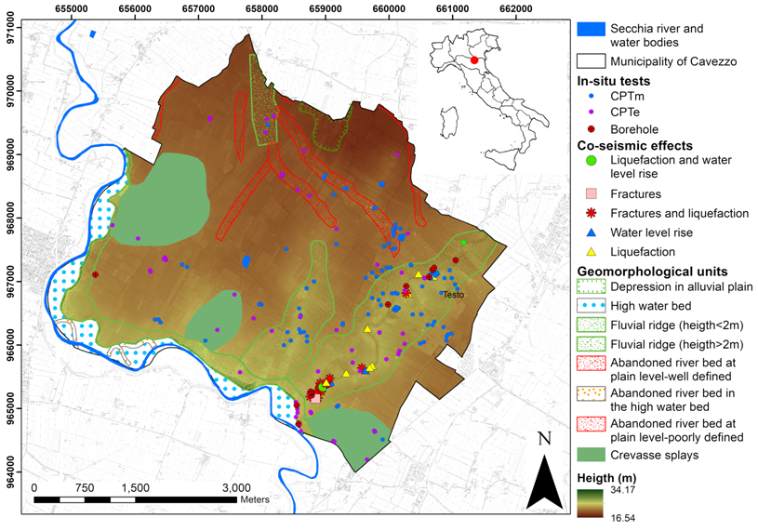

Figure 1. Main geological and geomorphological features of the area of Cavezzo (from Meisina et al., 2019).

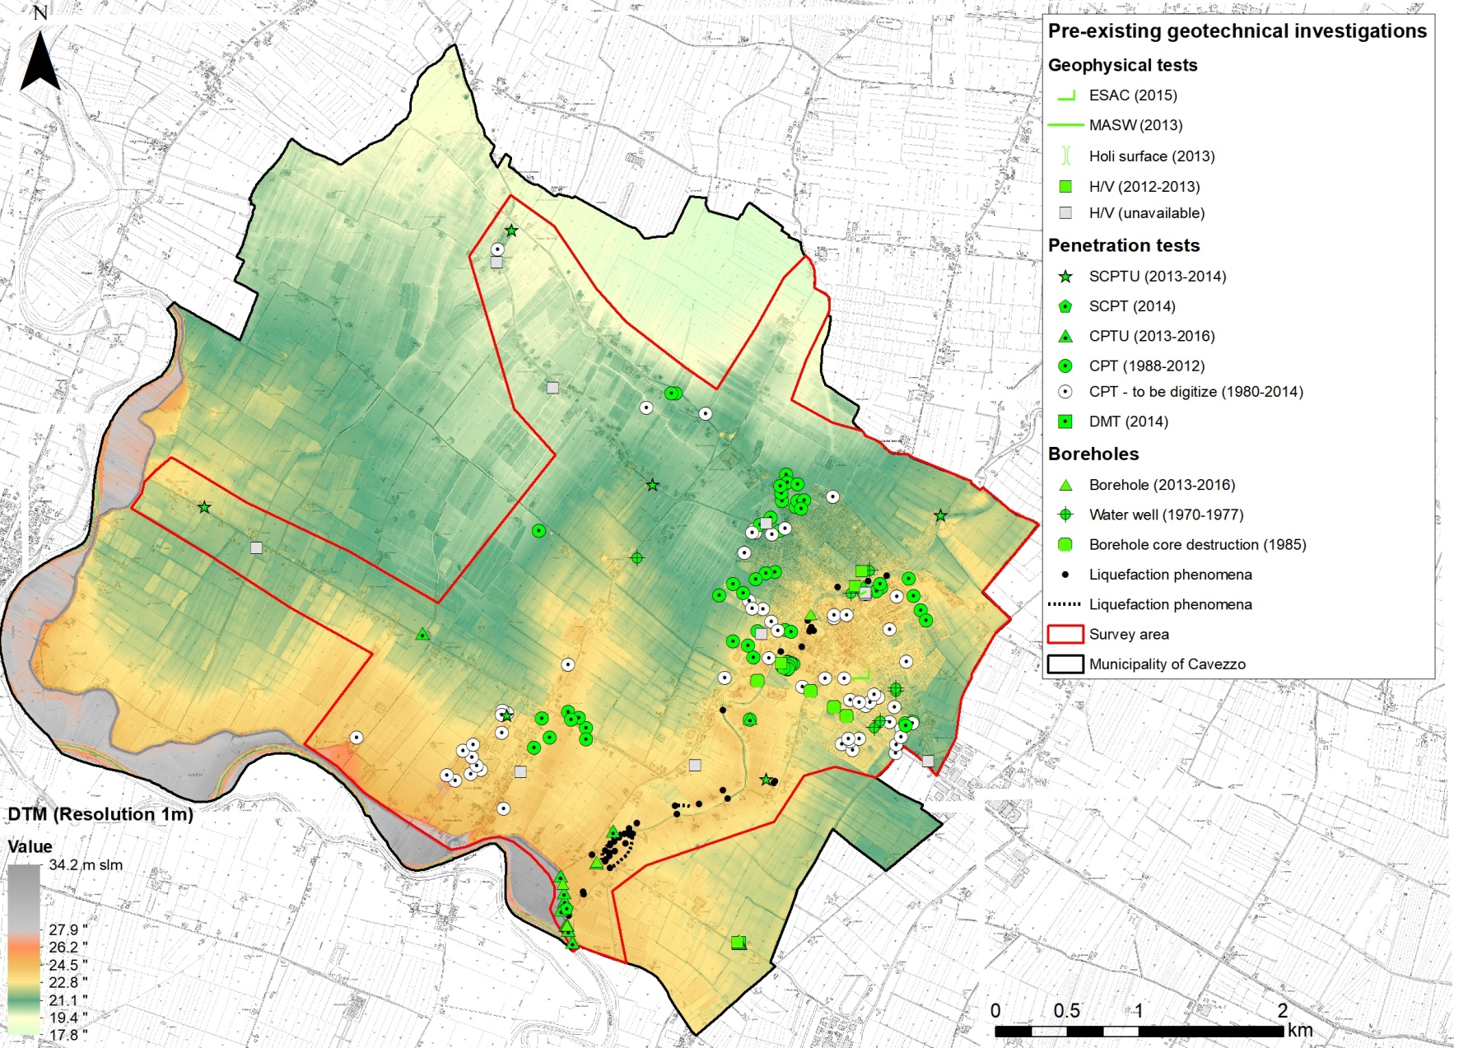
(a)
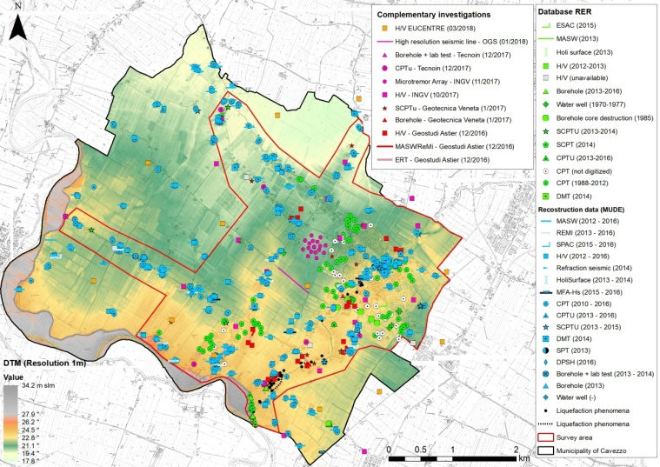
(b)

Figure 2. Comparison between the map showing the existing data available for the territory of Cavezzo before the LIQUEFACT project started in 2016 (a) and the map showing data acquired during the LIQUEFACT project for improving the ground characterization of Cavezzo territory (b). The manifestations of soil liquefaction occurred in 2012 sequence (black dots) and 1m resolution DEM are also superimposed. Modified from Lai et al. (2019).

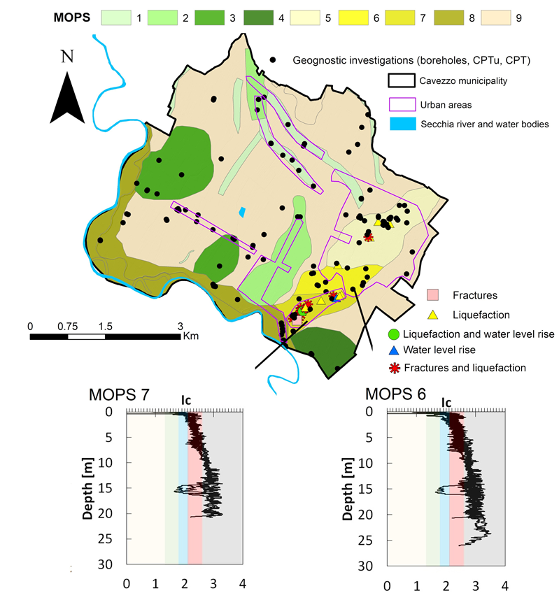

Figure 3. On top, map of 9 homogenous areas defined for Cavezzo municipality, while on bottom …. (from Meisina et al 2019).

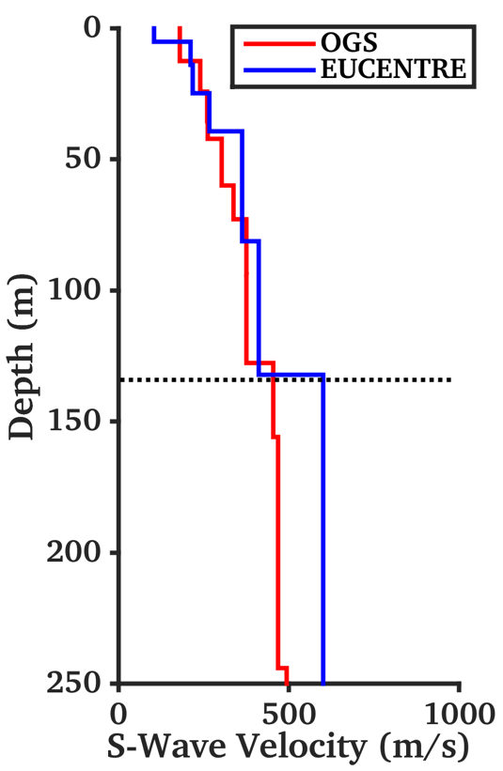

Figure 4. Comparison between two sample models from surface wave inversion of ambient vibration data (EUCENTRE) and from high-resolution P/S seismic reflection survey (OGS). The models show an overall good match down to a depth of about 140m, where an interface assumed to represent the seismic bedrock is located. Velocity is progressively mismatching the deeper layers.

A)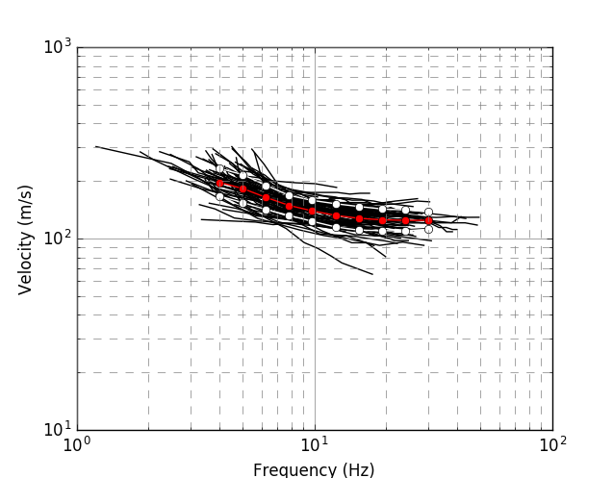
B) 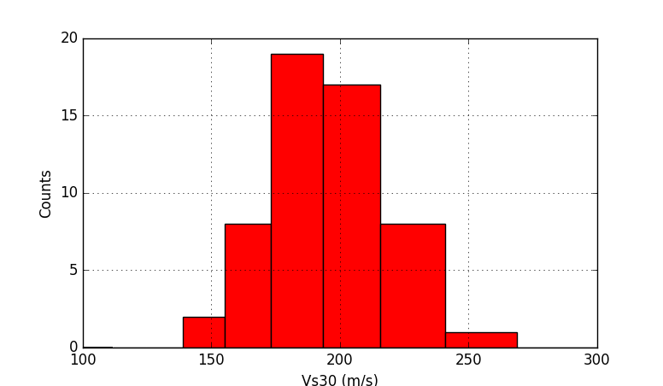

Figure 5. (A) Rayleigh wave dispersion curves form MASW analysis available for the territory (in black). Mean (red dots) and standard deviation (white dots) of the distribution is also presented to show the overall variability. (B) Distribution of the Vs30 values obtained from the λ_{40m} empirical approximation.

Figure 6. Map of amplification factor computed for Cavezzo considering the 475-years return period. Top left: PGA; Top right: Housner intensity ratio (0.1s≤T≤0.5s); Bottom left: Housner intensity ratio (0.5s≤T≤1.0s); Bottom right: Housner intensity ratio (0.5s≤T≤1.5s)

Figure 7. Calibration of shear modulus and damping ratio decaying curves as proposed by Darendeli (2001) using data from laboratory tests performed in December 2017 in Southern area of Cavezzo municipality.

