ASSESSING THE SPATIAL VARIABILITY OF GROUND MOTION FOR MICROZONATION PURPOSES: THE CASE STUDY OF CAVEZZO MUNICIPALITY (ITALY)

Lai^{1,2} C.G., Poggi³ V.*, Famà^{1,2} A., Zuccolo^{1,2} E., Bozzoni² F.*, Meisina⁴ C., Boni⁴ R., Martelli⁵ L., Massa⁶ M., Mascandola⁶ C., Petronio³ L., Affatato³ A., Baradello³ L., Castaldini⁷ D., Cosentini⁸ R.M.

¹Department of Civil and Architectural Engineering, University of Pavia, Italy
²European Centre for Training and Research in Earthquake Engineering, EUCENTRE, Pavia, Italy
³National Institute of Oceanography and Applied Geophysics, OGS, Trieste, Italy
⁴Department of Earth and Environmental Sciences, University of Pavia, Italy
⁵Geological, Seismic and Soil Survey, Emilia-Romagna Region, Bologna, Italy
⁶National Institute of Geophysics and Volcanology, INGV, Milano, Italy
⁷ Department of Chemical and Geological Sciences, University of Modena and Reggio Emilia, Italy
⁸Department of Structural, Building and Geotechnical Engineering, Politecnico di Torino, Italy

*Corresponding authors:
- Valerio Poggi, Researcher, Italian Institute of Experimental Oceanography and Geophysics, OGS, Trieste, Italy, vpoggi@inogs.it
- Francesca Bozzoni, Researcher, European Centre for Training and Research in Earthquake Engineering, Via Ferrata, 27100 - Pavia, Italy, francesca.bozzoni@eucentre.it

ABSTRACT
In July 2017, an inter-institutional agreement was signed among the University of Pavia, EUCENTRE, the administration of Emilia-Romagna Region, the Province of Modena and the Municipality of Cavezzo to perform a microzonation study at the town of Cavezzo (Modena, Northern Italy). This research study was led as part of the European H2020 project LIQUEFACT, initiated in May 2016 with the main goal of establishing guidelines for the assessment and mitigation of damages to structures and infrastructures caused by earthquake-induced soil liquefaction. Within this framework, the municipality of Cavezzo was selected, among four European testbed territories, as case-study for mapping the liquefaction hazard at urban scale with the ultimate goal of drawing up a microzonation chart.
Seismic microzoning represents a basic tool for prevention activity planning and land management. An extensive and detailed microzonation study was performed with reference to the territory of the Municipality of Cavezzo, damaged during the seismic sequence hitting Emilia-Romagna Region, Northern Italy, in 2012. In this paper, we discuss the work carried out in Cavezzo to characterize the spatial variability of ground motion amplification due to local soil conditions in the municipality area.
A multi-disciplinary approach is presented, involving geotechnical engineers, geophysicists, geologists and seismologists from different institutions, with the goal of thoroughly characterizing the territory using complementary techniques at different scales and with different level of resolution and confidence. A considerable amount of geomorphological, geological, hydrogeological, seismological, geotechnical and geophysical investigations was collected and processed for the purpose. A GIS-based (Geographic Information System) platform was initially setup to manage the gathered data, which now includes the outcomes of about 1,000 geotechnical and geophysical tests. Such extended dataset was then used as primary constraint for the creation of a comprehensive pseudo-3D geotechnical and a seismo-stratigraphic model of the territory, consisting of a dense grid of one-dimensional vertical profiles to depict the variability of the soil properties over the area. The model was finally used as the input for linear-equivalent ground response analyses. For the calculation of the amplification factors, special emphasis was given to the treatment and propagation of the uncertainties of the model parameters, whose different realizations have been accounted though a logic tree approach.

- INTRODUCTION
The seismic microzonation of a territory is the process that aims at identifying and mapping the subsoil seismic response and earthquake-induced phenomena of that territory. Typically, the spatial scale at which the zonation is performed is that of a municipality (urban scale) and it involves both the phenomenon of ground shaking amplification and ground instabilities. In this framework, the seismic microzonation plays a crucial role in earthquake risk reduction, providing a valuable input for urban planning (e.g. Ansal et al. 2009, 2010, Crespellani 2014, Celikbilek and Sapmaz 2016, Aversa and Crespellani 2016, etc.).
In the last few decades, efforts were made to perform microzonation on different earthquake-prone areas. Fäh et al. (1997) carried out a detailed microzonation of the city of Basel to compute expected ground motion during seismic events. Tuladhar et al. (2004) performed a seismic microzonation for the city of Bangkok by using micro-tremor observations. Anbazhagan and Sitharam (2008) mapped the average shear wave velocity for the Bangalore region in India and proposed also an empirical relationship between the Standard Penetration Test blow count and shear wave velocity. Cox et al. (2011) presented a seismic site classification microzonation of the city of Port-au-Prince based on shear wave velocity of the soil and provided a code-based classification scheme for the city. Murvosh et al. (2013) carried out shear wave velocity profiling in complex ground to enhance the existing microzonation of Las Vegas. Motalleb Nejada (2018) developed a microzonation algorithm that combines neural networks and geographic information system (GIS), in which the field and laboratory data are used as inputs for developing the microzonation of shear wave velocity and soil type of a selected site. Among the most recent and significant experiences in the field of seismic microzonation for ground shaking, it is worth mentioning the intensive studies, that have been performed after the 2016-2017 Central Italy seismic sequence, to obtain detailed microzonation maps in the 137 municipalities most damaged by the earthquakes (Crespellani et al., 2019).
In Italy, the national reference document for seismic microzonation is the “Guidelines for Seismic Microzonation” (SM Working Group, 2015). guidelines and criteria to achieve seismic microzonation have been standardized and published in Working Group ICMS (2008, 2011) by the Conference of Italian Regions and Autonomous Provinces, and the Italian Civil Protection Department. It establishes criteria and operational instructions for the identification of areas subjected to ground amplification and ground instabilities (i.e. slope instability, soil liquefaction and ground failures) to guide the urban planning of local administrators. Similarly to the guidelines of seismic microzonation issued by the TC4-ISSMGE (1999), three levels of microzonation studies are identified: level 1 is the basic level and it relies on gathering existing geologic, geomorphologic and hydrogeological data which are processed to roughly subdivide the investigated territory into a certain number of homogeneous zones where the expected seismic hazard intensity or risk of ground failure is uniform. The resolution scale in grade 1 microzonation is low. Level 2 on the other hand, is based on using existing geologic data and abaca containing coefficients for ground amplification. Non-invasive geophysical surveys are encouraged. Level 3 is the most detailed level of microzonation. As such, it requires purposely-planned geotechnical and geophysical investigations as well as numerical ground response analyses, for a quantitative definition of seismic hazard and geological-geotechnical risks. Whereas level 1 and 2 microzonation are commonly performed in Italy, a level 3 study is restricted to few municipalities of special interest, given the considerable time and financial investment required.
One of the main goals of the H2020 European project LIQUEFACT 2016-2019 (http://www.liquefact.eu/) is the definition of objective criteria to assess liquefaction hazard at different geographic scales. The project, initiated in May 2016 and ending in October 2019, also aims at addressing other risk-related aspects of liquefaction potential, including the impact to structures and infrastructures of earthquake-induced soil liquefaction as well as mitigation of liquefaction risk through ground improvement techniques. LIQUEFACT Work Package 2, led by University of Pavia and EUCENTRE, deals with zonation of a territory both at continental (macro-zonation) and sub-municipal scale (micro-zonation). In this framework, four European testbed territories were selected as case-studies where to perform seismic microzonation for earthquake-induced liquefaction hazard. The four target areas have been selected in Emilia-Romagna region (Northern Italy), Lisbon metropolitan area (Portugal), Ljubljana area (Slovenia) and in Marmara region (Turkey). The territory of the Municipality of Cavezzo have been chosen as Italian case-study, since it experienced the 2012 seismic sequence occurred in Emilia-Romagna Region (e.g. Tertulliani et al. 2012, Locati et al. 2016, Rovati et al. 2016, etc.), where widespread liquefaction manifestations occurred (e.g. Martelli and Romani 2013, Fioravante et al. 2013, Lai et al. 2015, etc.). In this framework, an inter-institutional agreement was signed in July 2017 involving the University of Pavia, EUCENTRE, the administration of Emilia-Romagna region, the administration of the Province of Modena and the municipality of Cavezzo to perform a level 3 microzonation study of the territory of Cavezzo, according with the Italian guidelines for seismic microzonation to support territorial and urban planning (Working Group ICMS 2008, 2011), named “Guidelines for Seismic Microzonation” (SM Working Group, 2015). Although the study was focused on the assessment of liquefaction hazard at urban scale, this paper presents a summary of the research activities carried out in performing the seismic microzonation of Cavezzo with special reference to ground shaking. In particular, the creation of a detailed seismo-stratigraphic model from the analysis of existing and newly acquired geotechnical and geophysical data will be illustrated. Special attention is given to the treatment and propagation of the uncertainties due to both the overall variability of the input data and that associated with data processing and modeling assumptions. The interdisciplinary nature of the conducted work is highlighted, discussing the adopted methodological approaches, the diversity of data calibration and the way these challenges have been collectively handled to create a unified yet comprehensive ground motion amplification model.

- GEOLOGICAL AND SEISMOTECTONIC SETTING
Cavezzo municipality is located within the northern sector of the Modena province (Italy), on the right side of the Secchia River (Figure 1a). The study area sits within the western margin of the Po plain, a large foreland sedimentary basin originated by the progressive convergence of the Africa/Adria and Eurasia plates initiated during the late Cretaceous and still ongoing. Such compressional regime led to the development of large thrust and folds structures with roughly WNW-ESE trending, but of opposing vergence to the North and to the South of the longitudinal valley axis. Some of the southern buried structures have demonstrated to be still under active shortening, causing non-negligible historical seismicity, whose noticeable expression was the recent 2012 Emilia sequence. For further details, the reader can refer, among others, to Pieri and Groppi (1981), Toscani et al. (2009), Fantoni and Franciosi (2010), Bignami et al. (2012), Turrini et al. (2014).
The sedimentary infill of the Po plain consists of a thick sequence of sediments of Tertiary-Quatertiary age, from fine Pliocene muds to more course silt, sand and gravel alternations due to transition to continental deposition from the Pleistocene. Depositional sequence is heavily perturbed by the ongoing deformation process and the alternation of episodes of erosion and glaciation, which have generated several noticeable angular unconformities and gaps (Mascandola et al. 2019).
At local scale, Cavezzo is on the southern limb of the buried Mirandola antiform (Boccaletti et al., 2004; Martelli et al., 2017, Figure 1b). The lithostratigrafic succession of the area is composed by alluvial deposits ranging in thickness from around 130 m in the northern area to 280 m in the southern one (RER-ENI, 1998). The geological bedrock is constituted by interbedded marlstones and sands of the Pliocene and Lower Pleistocene “Argille Azzurre” Formation and Middle Pleistocene “Imola Sands” Formation (RER-ENI, 1998). The alluvial deposits in the Cavezzo area are characterized by interbedded fine silty-clayey soils with layers rich of peat and interbedded sands and silty sands. These surficial sediments were deposited by the Secchia River, whereas the deeper sand layers were deposited by the Po River (Castaldini, 1989).
From the morphological point of view, the study area is located in the alluvial plain of the Secchia River, ranging in elevation from 34 m a.s.l. in the southern and western sector to around 20 m a.s.l. in the northern part. It is worth noting that the highest topographic level is reached in correspondence of the modern artificial levees of the Secchia River, which raise about 7-8 m above the surrounding area (Figure 2). The study area includes different geomorphological features interpreted as floodplain, fluvial ridges and crevasse splays. The subsoil of Cavezzo is mainly characterized by silty-clayey sequences including channel-filling and crevasse splay sand layers (Pellegrini and Zavatti, 1980).

- METHODOLOGY
A seismic response of the study area was performed following four major steps, which are here briefly summarized.
- First, all existing geotechnical and geophysical measurements already available for the territory have been collected and organized in a comprehensive GIS database. The database has been subsequently extended with a number of new ad-hoc geophysical investigations on selected strategic locations.
- A 3D geological/lithological model for the uppermost 30m was then constructed integrating boreholes and CPT data. The resulting model, extending over an area of approximately 27 km², has been used for the identification of major surface lithological units (LU) and for the assessment of the liquefaction potential.
- Next, a large-scale seismo-stratigraphic model was developed based on a combination of active and passive seismic data, including single measurement and 2D arrays ambient vibration analyses and high-resolution P and S reflection prospecting. The model consists of a grid of 2,984 nodes with 0.001 degrees spatial resolution (about 100 meters). For each grid node, a set of 11 complementary 1D vertical seismo-stratigraphic S-wave velocity profiles was identified to account for the uncertainties associated to the investigations. The resulting pseudo-3D model extends down to about 200m depth.
- The previous geological/lithological and seismo-stratigraphic models were finally combined for the calculation of the seismic amplification factors through numerical ground response analyses using a stochastic approach. Seven spectrum-compatible accelerograms defined for 475, 975, and 2,475 years return periods were selected as input motion (referred to outcropping rock conditions). The 1D soil amplification function was then computed for each grid node and each velocity profile using a linear-equivalent soil constitutive model, for a total of 229,768 analyses. The different amplification results were finally combined using the logic-tree approach to rationally account for the epistemic uncertainty associated to the velocity model and the reference input variability.
In the following sections, the different steps of the proposed methodology are discussed in details.

- GROUND CHARACTERIZATION DATASET
To carry out ground response analyses, an accurate knowledge of the geotechnical characteristics of the shallow subsoil at the site is required. At this purpose, the territory of Cavezzo was thoroughly characterized from geomorphological, geological, hydrogeological, seismological, geotechnical and geophysical viewpoints.
As a start, existing data retrieved from trench pits, boreholes, piezometric, in situ and laboratory geotechnical and geophysical investigation campaigns were gathered. Figure 3 (a) shows the existing data available for ground characterization of the territory of Cavezzo before the LIQUEFACT project started. Based on the quality and quantity of the retrieved existing data, then, complementary ground investigation campaigns were purposely devised. Table 1 includes the type and number of tests adopted for the ground characterization of the territory of the Cavezzo Municipality. In-situ geotechnical investigations included cone penetration tests with acquisition of the excess pore water pressure (CPTu) and the shear wave velocity Vs (SCPTu), standard penetration tests (SPT) and drilling of boreholes. Laboratory tests were also performed on undisturbed soil samples retrieved with the standard Osterberg sampler and the innovative gel-push technique for coarse-grained materials (Cubrinovski et al., 2016).
A number of non-invasive geophysical tests were also performed. These included 3D electric tomography, active and passive seismic surveys. In this regard, fundamental was the contribution of the National Institute of Geophysics and Volcanology (INGV Milano) and the National Institute of Oceanography and Applied Geophysics (OGS, Trieste), who respectively led a large-scale ambient vibration survey (including single-station H/V spectral ratio and 2D array measurements) and a high-resolution P/S reflection seismic survey. Such combined geophysical prospecting allowed illuminating large volumes of soils and at great depths (> 200 m from the ground surface) to identify the location of the seismic bedrock, while providing a mean to correlate the results obtained at different locations from the conventional geotechnical tests.
All data gathered on the subsoil of Cavezzo were organized into a purposely-developed GIS database, which now includes the data of more than 1,000 geotechnical and geophysical tests, as shown in Figure 3 (b, c). Data of both 1m and 5m resolution DEM were also included.

- MODELING OF THE SUBSOIL

  - Geotechnical/lithological model
Based on a joint analysis of stratigraphic, lithological and geomorphological data, the territory of Cavezzo was tentatively subdivided into a number of geologically homogenous zones (MOPS), identified using an approach described in detail in a previous work by Meisina et al. (2019), which includes also the typical stratigraphic logs derived for each zone. Specifically, 9 main geological domains have been identified based on joint stratigraphic analysis of boreholes and water wells and from the interpretation of CPTu/CPT tests. These domains were used to separate zones of supposedly homogeneous lithological and genetic depositional characteristics (Figure 4). For the stratigraphic interpretation of CPTu/CPT data, it was used a correction of Soil Behaviour Index (Ic, Robertson 2009) calibrated using the available CPTu tests and boreholes data (Meisina et al., 2019) in order to identify the mixture layers falling within the transition zone of the reference chart (Robertson, 2009).

  - Seismo-stratigraphic model
The previously described lithological model was preliminary to the definition of the seismo-stratigraphic idealization of the subsoil, which was obtained by integrating the existing geophysical data (mostly from shallow MASW investigations) with purposely-planned active and passive seismic acquisitions. In the following, the different steps for the creation of the seismo-stratigraphic model are described.

    - Calibration of the reference velocity model
As a first step, assuming a smooth lateral variability of the geophysical parameters over the investigated area, a set of reference one-dimensional seismic velocity profiles were established at selected representative locations. The different profiles were derived from two independent although complementary geophysical approaches, based respectively on the array analysis of ambient vibrations (hereinafter called the EUCENTRE model) and from the processing of high-resolution reflection of P/S seismic data (hereinafter called the OGS model).
Concerning the analysis of ambient vibration data, the velocity profiles were obtained from combined inversion of multi-component surface wave information (Poggi and Fäh. 2010). Love and Rayleigh velocity dispersion curves were first derived using the high-resolution frequency-wavenumber analysis on the three-component of motion (3CFK) as proposed by Poggi and Fäh (2010). This technique is beneficial in that it allows an efficient separation of the transversal (Love) and radial (Rayleigh) surface wave motion from the horizontal components (Figure 5), providing the dispersion information of both wave types and, at the same time, an unbiased estimate of the Rayleigh ellipticity (or polarization) function within the resolved frequency band. The one-dimensional seismic velocity profile is then obtained by combined inversion of Love and Rayleigh wave dispersion, including higher modes, the Rayleigh wave polarization function and fundamental frequency of resonance of the site (f₀) from H/V analysis. The Open Source software Dinver (Wathelet et al., 2008) is used to perform inversion though an enhanced version of the neighborhood algorithm. The use of Love wave dispersion curves, which is generally uncommon, has the particular advantage to provide a unique constraint to the S-wave velocity of the medium. In combination with Rayleigh wave information (dispersion and ellipticity), then, it allows a more reliable estimation of the seismo-stratigraphic model. Complementary, the OGS velocity model has been derived from interval velocity analysis of P- and S-wave reflection seismic (see Petronio et al. 2018 for more details).
The two seismic techniques have shown to produce consistent results down to about 160~170 m depth from the ground surface, while some deviations were observed at larger depths (Figure 6). Such discrepancy is likely due to the intrinsic limitations of passive seismic analysis, whose resolution decreases progressively with increasing wavelength and investigated depth. On the contrary, seismic reflection methods generally provide a more accurate imaging of the profile, particularly on the layer interfaces, though at the expense of a less robust velocity estimation. In the present case, the two sets of velocity profiles explain the observed data equally well (e.g. Figure 7). Since it was not possible to resolve the ambiguity of the interpretation, the models have been therefore considered both equally reliable and representative of the epistemic uncertainty of the reference seismo-stratigraphic models. Such variability is accounted for in the data processing by means of a logic-tree calculation approach.

    - Soil variability of the study area
In a subsequent step, at each point of the pseudo-3D model the shear wave velocity profiles have been adjusted to match the observed variability of both the shallow subsoil and the deepest resonating layer interface (which was assumed to be the local seismic bedrock). To constraint the shallow portion of the velocity model, a map of the Vs30 variability was first obtained from existing MASW analyses from 83 previous surveys available for the study area. It should be noted that being the results from available MASW data heterogeneous (e.g. they were obtained from different contractor and using different processing schemes), it was decided to homogenously reassess the V_{S30} of each measurement by means of a simplified procedure as proposed by Brown et al. (2000) and further developed by Martin and Diehl (2004) and Albarello and Gargani (2010) (see also Comina et al. 2011 for clarifications). In short, the V_{S30} at each site was obtained empirically from the Rayleigh wave dispersion curve (Figure 8a) by extracting the phase velocity corresponding to a wavelength (λ) of 40 m, which provided estimates of V_{S30} (Figure 8b) comparable with those obtained from independent processing.
Spatial interpolation of the V_{S30} values was subsequently performed using widely used geostatistic algorithm, i.e. ordinary Kriging (Isaaks and Srivastava, 1989). This provided a mean shear wave velocity and the corresponding residual uncertainty at each point of the interpolated grid. Finally, at each location of the gridded model, the reference velocity profiles have been adjusted to match the interpolated V_{S30} value from MASW analysis (Figure 9a). The adjustment was performed by applying a depth-dependent velocity correction factor ($γ$), whose effect progressively decreases with the increase of depth, following a negative exponential function, ensuring that the observed shallow variability of V_{S} does not sensibly impact the seismo-stratigraphic model at large depth:

$$γ(α, z)=α*e^{-z/β}$$ | (1)

where $α$ is a free coefficient, while $β$ is a fixed curvature parameter used to tweak the sensitivity of the correction to depth. The adjustment coefficient $α$ is found by solving the minimization problem:

$$\underset{α}{argmin}\left(\frac{30}{\int_{0}^{30}{\frac{z}{γ(α, z)*Vs(z)}dz}}-{Vs}_{30}^{Obs.}\right)$$ | (2)

The curvature parameter $β$ was empirically set to 100 after direct inspection of the modified velocity profiles.

    - Mapping the seismic bedrock
The variability of the seismic bedrock was obtained using an adaptation of the procedure proposed by Poggi et al. (2012), based on Rayleigh wave ellipticity peak matching.
As starting point, a map of the fundamental frequency of the area was created by interpolation of 26 f₀ values from single station ambient vibration measurements obtained using horizontal-to-vertical-ratio spectral analysis (e.g. Nogoshi & Igarashi 1971; Nakamura 1989; Haghshenas et al. 2008). Consistently with the procedure used to map shallow velocity variability, spatial interpolation of the sparse f₀ values was performed using ordinary Kriging, accounting also for the associated uncertainty.
Subsequently, the one-dimensional velocity profiles at each grid point of the seismo-stratigraphic model have been adjusted to match the observed (thus interpolated) resonance frequencies. However, in contrast to what was previously done to account for Vs30 variability, in this case the adjustment was not performed directly on velocity, but by applying a depth migration coefficient to the profile’s layer interfaces. It must be noted that using a coefficient instead of simple depth shift has the advantage to impact mostly the deep layer interfaces, while leaving substantially unmodified the uppermost portions of the velocity profile, already constrained by other information (e.g. surface wave dispersion, Vs30).
The resulting geophysical bedrock agrees with the expected geological features of the area (Figure 9b), with a moderate North-South trend, related to the geometry of the nearby Mirandola anticline structure, although with a noticeable irregularity in a small region in the central part of the model.

  - Final geotechnical-seismic model
The final geotechnical-seismic model of the area of study was defined starting from the pseudo-3D seismo-stratigraphic model, consisting of 10 V_{S} EUCENTRE profiles each with an associated weight of 0.05 (overall weight equal to 0.5), and an OGS V_{S} profile from seismic reflection survey to which a weight of 0.5 was associated. Each independent 3D model consisted of 2,984 1D V_{S}-profiles at each node of a reference grid that covers the territory of Cavezzo. Therefore, a total of 32,824 V_{S} profiles (2,984x11) were defined and used for ground response analysis. Furthermore, for each profile a unique seismo-geotechnical model was created by merging the soil properties of the geological/lithological and geophysical models. At this purpose the 9 geologically homogeneous zones discussed in § 3.2 were used jointly with their associated uncertainties. In each homogeneous zone, the nodes of the reference grid falling within its boundaries have been identified for each layer of 11 seismo-stratigraphic models and a statistical analysis of the corresponding thicknesses was performed.
An equivalent-linear approach has been adopted to approximate the non-linear, inelastic behaviour of soils. For such purpose, laboratory tests aimed at evaluating the evolution of shear modulus and damping ratio with shear strain should be ideally available for each soil layer. The experimental data from laboratory tests performed in the Southern part of the Cavezzo in December 2017, were referred to a limited area of the whole territory under investigation, thus appropriate literature relationships have been adopted. Indeed, a purposely-devised calibration of the shear modulus and damping ratio decaying curves was accomplished following the methodology proposed by Darendeli (2001) coupled with the results of resonant column (RC) tests available for a few samples taken in Cavezzo.
Since the assessment of ground amplification was performed using 1D linear-equivalent analysis, a purposely-devised calibration of the shear modulus and damping ratio decaying curves was accomplished following the methodology proposed by Darendeli (2001) coupled with the experimental data from laboratory tests performed in the area of study in December 2017.

- SEISMIC RESPONSE FOR MICROZONATION

  - Definition of the reference seismic input and its variability
Emilia-Romagna region issued in 2015 (DGR n.2193) regional guidelines to support territorial and urban planning, which are consistent with the national guidelines for seismic microzonation available in Italy “Guidelines for Seismic Microzonation” (SM Working Group, 2015). These regional guidelines provides 3 real accelerograms recorded on outcropping bedrock to be used as input motion for ground response analyses. It must be noted, however, these signals are not independent from each other; in addition, they are referred only to the 475 years return period. Thus, they are unsuitable to the scope of the study. Consequently, the seismic hazard at the site was defined in terms of seismo- and spectrum- compatible natural accelerograms for three return periods (475, 975 and 2475 years). Spectrum-compatibility was enforced with reference to 5% damped, elastic acceleration response spectra (horizontal component of motion) referred to stiff ground conditions specified by the current Italian building code (NTC, 2018).
Table 1 summarizes, for each considered return period, the parameters required to define the elastic response spectra for soil class A with reference to Cavezzo: a_{g} is the horizontal peak ground acceleration on a rigid reference site, F₀ is the amplification factor of the horizontal acceleration spectrum and T_{C*} is the upper limit of the oscillator period of the constant spectral acceleration branch.
For each return period, a suite of 7 independent natural accelerograms recorded on free-field rock ground conditions, spectrum-compatible with the elastic response spectrum defined by the NTC (2018) for the territory of Cavezzo was selected. The selection was made using an updated version of ASCONA computer program (Corigliano et al., 2012), which provides a set of strong motion recordings satisfying specific seismological criteria (e.g., magnitude and distance ranges, spectral shape), with the additional requirement of being compatible with a target spectrum (in this case, the elastic acceleration response spectrum prescribed by the current Italian building code), in a specified oscillator period range (in this case, from 0.15 s to 2 s). Regarding record scaling, the PEER (2010a, 2010b) approach was adopted. Among different accelerogram sets that satisfy the requirements, the set returned by ASCONA is the one characterized by the minimum average deviation of the average response spectrum (of the 7 accelerograms) with respect to the target spectrum.

  - Ground response analyses
One-dimensional ground response analyses were carried out in Cavezzo territory using SHAKE91 (Schnabel et al., 1972; Idriss and Sun, 1992) coupled with the linear-equivalent soil constitutive model. The analyses were conducted for 3 return periods, 7 accelerograms, 2,984 nodes of the reference grid for which the geotechnical-seismic pseudo 3D (P3D) model was defined and 11 V_{S} profiles, for a total of 229,768 analyses. For each analysis, amplification factors (F_{i}) in terms of peak ground acceleration, Housner intensity ratio (computed considering 4 different oscillator period ranges) and acceleration response spectrum integral ratio in the spectral interval between 0.1s and 0.5s were computed. At each node of the grid and for each return period, the F_{i} values computed from the 7 accelerograms and 11 V_{S} profiles were averaged as follows:

(3)
where w_acc_{j} is the weight of the accelerogram, assumed to be the same for all accelerograms (w_acc_{j}=1/7), w_mod_{k} is the weight of the P3D model (w_mod_{k}=0.05 for each of the 10 models based on EUCENTRE data and w_mod_{k}=0.5 for the OGS model), while F^{i}_{jk} is the amplification factor F_{i} associated with the j-th accelerogram and the k-th P3D model.
It should be remarked that the suitability of 1D modelling in Cavezzo, mostly characterized by a stack of homogeneous flat and parallel layers with a negligible slope of the bedrock roof (around 5% in its steepest part), was confirmed by a 2D ground response analysis performed with QUAD4M (Hudson et al., 1994). In fact, the 2D analyses, which were performed with reference to a 110 m – long section crossing Cavezzo along the NS direction (i.e. the one with the largest variability in the sloping of the bedrock roof), allowed to obtain amplification factors similar to those obtained by 1D analyses. From the comparison of the results from 1D and 2D ground response analyses it was inferred that for the frequencies of interest in the microzonation study, 2D effects are negligible.

- SEISMIC GROUND RESPONSE RESULTS
Figure 10 shows the map of the ground motion amplification factors computed for the municipality of Cavezzo for the 475 years-return period. According to the prescription of the 2015 (DGR n.2193) Emilia Romagna guidelines, the amplification factors (Fi) have been computed in terms of both peak ground acceleration (FPGA, expressed as PGA/PGA0 ratio) and Housner intensity ratio (expressed as SI/SI0), computed for 3 different oscillator period ranges: FH0.1-0.5s, FH0.5s-1.0s, FH0.5-1.5. The terms PGA0 and SI0 are respectively the peak ground acceleration and Housner intensity related to the reference input motion. It is evident that high-frequency ground motion (PGA and FH0.1s-0.5s) is characterized by lower amplification factors: they range between 1.0 and 1.5 for PGA and 1.3 and 1.9 for FH0.1s-0.5s. Higher amplification factors are obtained for the high period range, namely FH0.5s-1.0s and FH0.5-1.5. Indeed, amplification factors for FH0.5s-1.0s are greater than 3 for the whole territory under investigation and reach values of 3.9 in the northern part of the municipality. Housner Intensity at longer periods (FH0.5-1.5) exhibits amplification factors ranging from 2.6 and 3.3.
According to expectation, the largest absolute amplification factors are experienced in the northern part of the municipality, in the proximity of the culmination of the Mirandola anticline, where the seismic bedrock is shallower and the resonance effects became significant in the periods of engineering interest., which is clearly visible in the four maps. Additional ground motion variability is locally visible, due to the combined effect of Vs30-constrained uppermost seismic velocity variability and the differences in lithological and genetic depositional environment.
It is interesting to note that the maps in Figure 10 clearly reflect the geometry of homogeneous zones showed in Figure 4. The boundaries of these areas can be seen in trend with the values of the amplification factors. The impact on ground motion is however different for the different intensity measures. For instance, this fact is clearly visible in the high period range, namely FH0.5s-1.0s (bottom left) and FH0.5-1.5 (bottom right); lower values of amplification factors were obtained in homogeneous zones, named 3 and 4 which are the crevasse splays identified within the Cavezzo territory.

- DISCUSSION AND CONCLUSIONS
From the results of ground amplification analyses it is readily apparent the correlation between the spatial variability of surface ground motion within Cavezzo territory and the characteristics of the adopted seismic-geotechnical and seismo-stratigraphic models. This clearly highlights the importance of the interplay and complementarity among different methodological approaches and spatial resolution scales characterizing a seismic microzonation study when tackled from a geological, geophysical, seismological and geotechnical prospective. The challenge to succeed in such a study consists in explicitly recognizing its intrinsic multi-disciplinary nature in pursuing the goal of defining a unified subsoil model that harmonizes coherently the different scales at which it can be visualized.
It must be remarked however that the procedure illustrated in this article, strictly applies to situations where the geological setting is such that a smooth spatial variation of the subsoil properties over the territory, is an acceptable approximation, at the points of the calculation grid. In case of evident 2D/3D response, the use of more advanced numerical models will be unavoidable. Nonetheless, such condition must be evaluated carefully on a case by case scenario, e.g. by a preliminary inspection of the H/V spectral ratio variability across the area, in order to justify the increased investment required for such advanced and computationally very expensive analysis. So far, very few attempts are available in the literature to objectively quantify the possibility of 2D/3D morphological effects, which makes this subject an open field of research.
It is also important to underline that ground response analyses were conducted using a linear equivalent soil constitutive model. This approach of adopting one-constituent, equivalent-linear viscoelastic rheology for the soil is inadequate to correctly reproducing the seismic response of geomaterials exhibiting strong nonlinearities in the hydro-mechanical behaviour. An example is constituted by liquefiable soils, which require ground response analyses to be more correctly conducted using effective stress-based soil constitutive models. In the territory of Cavezzo, widespread liquefaction phenomena were observed during the 2012 seismic sequence with specific reference to the south-eastern part of the municipality. Thus, at least for these sites, effective-stress ground response analyses are required. This type of analyses is currently ongoing for the areas in Cavezzo prone to exhibit liquefaction occurrences.
Finally, an advancement of the current achievements in the seismic microzonation of Cavezzo territory could be represented by a complete randomization of all soil parameters and other input data for ground response analyses so to produce a fully stochastic set of amplification factors.

ACKNOWLEDGMENTS
This research has been carried out within the framework of the European LIQUEFACT project. The LIQUEFACT project has received funding from the European Union’s Horizon 2020 Research and Innovation Programme under Grant Agreement No. 700748. This support is gratefully acknowledged by the authors. The study herein presented has been carried out by a multi-disciplinary working group. In this framework, the authors would like to acknowledge:
- Sonia Lorini, Daniele Conca, Alì G. Ozcebe, Massimiliano Bordoni, Pina Persichillo, Juan C. Gòmez Zapata, Giuseppe Cerra, Giacomo Perotti and Simone Ciaffaroni from University of Pavia;
- Daniela Fontana, Stefano Lugli and Alessandro Ghinoi from University of Modena and Reggio Emilia;
- Sara Lovati, Simona Carannante, Paola Morasca, Ezio D’Alema, Gianlorenzo Franceschina and Antonio Gomez from INGV (Milan Section);
- Alfio Barbagallo, Gino Cristofano and Daniele Sorgofrom OGS;
- Giulio Ercolessi from Emilia-Romagna Region;
- the Major of the Cavezzo Municipality and the technical staff in particular Agnese Malagoli.
A final thank goes to the two anonymous reviewers for their suggestions and constructive criticisms, which helped in improving substantially the quality of our manuscript.

REFERENCES
Ansal, A., Kurtuluş, A., Tönük, G. (2010). Seismic microzonation and earthquake damage scenarios for urban areas. Soil Dyn Earthq Eng 30:1319–1328.
Ansal, A., Tönük, G., Kurtuluş, A. (2009). Microzonation for urban planning. In: Tankut AT (ed) Earthquakes and tsunamis, geotechnical, geological, and earthquake engineering, vol 11. Springer, Dordrecht, 133–152.
Aversa, S., Crespellani, T. (2016). Seismic Microzonation: an essential tool for urban planning in seismic areas. UPLanD J Urban Plann Landsc Environ Des 1(1):121–152.
Bignami, C., Burrato, P., Cannelli, V., Chini, M., Falcucci, E., Ferretti, A., Gori, S., Kyriakopoulos, C., Melini, D., Moro, M., Novali, F., Saroli, M., Stramondo, S., Valensise, G., Vannoli, P. (2012) Coseismic deformation pattern of the Emilia 2012 seismic sequence imaged by Radarsat-1 interferometry. Ann Geophys 2012;55(4). https://doi.org/10.4401/ag-6157.
Boccaletti, M., Bonini, M., Corti, G., Gasperini, P., Martelli, L., Piccardi, L., Severi, P. & Vannucci, G. 2004: Carta sismotettonica della Regione Emilia-Romagna, scala 1:250.000. Note illustrative. Regione Emilia-Romagna–SGSS, CNR-IGG. SELCA, Firenze.
Castaldini, D. 1989. Evoluzione della rete idrografica centropadana in epoca protostorica e storica. Atti Conv. Naz. Studi "Insediamenti e viabilità nell'alto ferrarese dall'Età Romana al Medioevo". Cento 8-9 May 1987 Acc. delle Sc. di Ferrara, 115-134, Ferrara.
Celikbilek, A., Sapmaz, G. (2016). Risk management and microzonation in urban planning: an analysis for Istanbul. Disaster Sci Eng 2(2):59–66.
Cox, B.R., Bachhuber, J., Rathje, E., Wood, C.M., Dulberg, R., Kottke, A., Green, R.A., Olson, S.M. (2011). Shear wave velocity- and geology-based seismic microzonation of port-au-prince, Haiti. Earthq. Spectra, 27, 67–92.
Crespellani, T. (2014) Seismic microzoning in Italy: a brief history and recent experiences. Ing Sism 31(2):3–31.
Corigliano, M., Lai, C.G., Rota, M., Strobbia, C.L. (2012). “ASCONA: automated selection of compatible natural accelerograms”. Earthquake Spectra, 28(3): 965-987.
Cubrinovski, M., Stringer, M., Haycock, I. (2016). Experience with gel‐push sampling in New Zealand. http://www.nzgs.org.
Fäh, D., Rüttener, E., Noack, T., Kruspan, P. (1997) Microzonation of the city of Basel. J Seismol, 1, 87–102.
Fantoni, R., Franciosi, R. (2010) Tectono-sedimentary setting of the Po Plain and Adriatic foreland. Rendiconti Lincei Sci Fis Nat 2010;21:S197–209. https://doi.org/10.1007/s12210-010-0102-4.
Fioravante V, Giretti D, Abate G, Aversa S, Boldini D, Capilleri PP et al. (2013). Earthquake geotechnical engineering aspects of the 2012 Emilia-Romagna earthquake (Italy). Proceedings of the 7th international conference on case histories in geotechnical engineering, Chicago, Illinois, USA.
Haghshenas, E., Bard, P.-Y., Theodulidis, N. & SESAME WP04 Team, 2008. Empirical evaluation of microtremor H/V spectral ratio, Bull. Earthq. Eng., 6(1), 75–108.
Hudson, M.B., Beikae, M., Idriss, I.M. (1994). “QUAD4M, a Computer Program to Evaluate the Seismic Response of Soil Structures Using Finite Element Procedures and Incorporating a Compliant Base Center for Geotechnical Modeling”, Department of Civil and Environmental Engineering, University of California, Davis.
Idriss, J., Sun, J.I. (1992). SHAKE91 - a computer program for conducting equivalent linear seismic response analyses of horizontally layered soil deposits. University of California, Davis, USA.
Isaaks, E.H., Srivastava, R.M. (1989). An Introduction to Applied Geostatistics. Oxford University Press, New-York.).
Lai, C.G., Bozzoni, F., Mangriotis, M.D., Martinelli, M. (2015). Soil liquefaction during the May 20, 2012 M5.9 Emilia earthquake, Northern Italy: field reconnaissance and post-event assessment. Earthquake Spectra, 31(4), 2351-2373.
Lai, C.G., Meisina, C., Bozzoni, F., Conca, D., Famà, Özcebe, A.G., Zuccolo, E., Bonì, R., Poggi, V., Cosentini, R.M. (2019). Mapping the liquefaction hazard at different geographical scales. Proceedings 7th International Conference on Earthquake Geotechnical Engineering, 7ICEGE, Rome, Italy, 17-20 June, 2019.
Lo Presti, D., Sassu, M., Luzi, L., Pacor, F., Castaldini, D., Tosatti, G., Meisina, C., Zizioli, D., Zucca, F., Rossi, G., Saccorotti, G., & Piccinini, D. 2013. A Report on the 2012 Seismic Sequence in Emilia (Northern Italy). International Conference on Case Histories in Geotechnical Engineering. 3.
Locati, M., Camassi, R., Rovida, A., Ercolani, E., Bernardini, F., Castelli, V., Caracciolo, C.H., Tertulliani, A., Rossi, A., Azzaro, R., D’Amico, S., Conte, S., Rocchetti, E. (2016): DBMI15, the 2015 version of the Italian Macroseismic Database. Istituto Nazionale di Geofisica e Vulcanologia. doi:http://doi.org/10.6092/INGV.IT-DBMI15
Lugli S., Marchetti Dori S., Fontana D. 2007. Alluvial sand composition as a tool to unravel the Late Quaternary sedimentation of the Modena Plain, northern Italy. In: Arribas, J., Critelli, S., Johnsson, M.J. (Eds.), Sedimentary Provenance and Petrogenesis: Perspectives from Petrography and Geochemistry. Geological Society of America Special Paper, 420, 57-72.
Martelli, L, Romani, M (2013). Microzonazione sismica e analisi della condizione limite per l’emergenza delle aree epicentrali dei terremoti della pianura emiliana di maggio-giugno 2012 (Ordinanza del commissario delegato n. 70/2012), Relazione Illustrativa (in Italian); http://ambiente.regione.emilia-romagna.it
Martelli, L., Bonini, M., Calabrese, L., Corti, G., Ercolessi, G., Molinari, F. C., Piccardi, L., Pondrelli, S., Sani, F. & Severi, P. 2017. Carta sismotettonica della Regione Emilia-Romagna e aree limitrofe. Note illustrative. Regione Emilia-Romagna, Servizio geologico, sismico e dei suoli. D.R.E.AM. Italia.
Meisina, C., Bonì, R., Bordoni, M., Lai, C.G., Bozzoni, F. et al. 2019. 3D Geological model reconstruction for liquefaction hazard assessment in the Po Plain. Proceedings 7th International Conference on Earthquake Geotechnical Engineering, 7ICEGE, Rome, Italy, 17-20 June, 2019.
Motalleb Nejad, M., Momeni, M.S., Manahiloh, K.N. (2018). Shear wave velocity and soil type microzonation using neural networks and geographic information system. Soil Dyn. Earth. Eng., 104, 54–63.
Murvosh, H., Luke, B., Calderón-Macías, C (2013). Shallow-to-deep shear wave velocity profiling by surface waves in complex ground for enhanced seismic microzonation of Las Vegas, Nevada. Soil Dyn. Earth. Eng., 44, 168–82.
Nakamura, Y., 1989. A method for dynamic characteristics estimation of subsurface using microtremor on the ground surface, Quart. Records Railway Tech. Res. Inst., 30, 25–33.
Nogoshi, M. & Igarashi, T., 1971. On the amplitude characteristics of microtremor, Part II, J. seism. Soc. Japan, 24, 26–40.
NTC (2008). Norme Tecniche per le Costruzioni. Decreto del Ministero delle Infrastrutture del 14 gennaio 2008. Gazzetta Ufficiale, n. 29 del 4 febbraio 2008, Supplemento Ordinario n. 30, www.cslp.it, Istituto Poligrafico e Zecca dello Stato, Roma (in Italian).
NTC (2018). Norme tecniche per le costruzioni. Ministero delle Infrastrutture e dei Trasporti, Decreto Ministeriale del 17 gennaio 2018, Supplemento ordinario alla G.U. n. 8 del 20 febbraio 2018 (in Italian).
Paolucci, E., Albarello, D., D’Amico, S., Lunedei, E., Martelli, L., Mucciarelli, M. and Pileggi, D. (2015) A large scale ambient vibration survey in the area damaged by May–June 2012 seismic sequence in Emilia Romagna, Italy. Bull Earthquake Eng 13:3187–3206. DOI 10.1007/s10518-015-9767-5.
PEER (2010a). Technical report for the PEER ground motion database web application-Beta Version-October 1, 2010. Pacific Earthquake Engineering Research Center (PEER).
PEER (2010b). User’s Manual for the PEER ground motion database web application-Beta Version-October 1, 2010. Pacific Earthquake Engineering Research Center (PEER).
Pellegrini, M. & Zavatti, A. 1980. Il sistema acquifero sotterraneo tra i fiumi Enza, Panaro e Po: alimentazione delle falde e scambi tra falde, correlazioni idrochimiche”. Quaderni IRSA, 51(1), Roma.
Pergalani, F., Pagliaroli, A., Bourdeau, C., Compagnoni, M., Lenti, L., Lualdi, M., Madiai, Martino, S., Razzano, R., Varone, C., Verrubbi, V. (2019). Seismic microzoning map: approaches, results and applications after the 2016–2017 Central Italy seismic sequence. Bull. of Earth. Eng., 1–35.
Pieri, M., Groppi, G. (1981). Subsurface geological structure of the Po plain, Italy. Pubbl. 414, Consiglio Nazionale delle Ricerche, CNR, agip. Rome: Progetto Finalizzato Geodinamica; 1981. p. 23. 1981.
Petronio L., Affatato A., Baradello L., Barbagallo A., Cristofano G., Sorgo D., Lai C.G., Poggi V., 2018. Shear wave seismic reflection survey in the 2012 Emilia epicentral area. 38th GNGTS, Bologna, Italy.
Poggi, V. and Fäh, D., 2010. Estimating Rayleigh wave particle motion from three-component array analysis of ambient vibrations. Geophys. J. Int., Volume 180, Issue 1, 251-267.
Poggi, V., Fäh, D., Burjánek, J. and Giardini, D., 2012. The use of Rayleigh wave ellipticity for site-specific hazard assessment and microzonation. An application to the city of Luzern (Switzerland). Geophys. J. Int., Volume 188, Issue 3, 1154-1172.
RER–ENI. 1998. Riserve idriche sotterranee della Regione Emilia-Romagna. G. M. Di Dio. Regione Emilia- Romagna, ENI Agip Divisione Esplorazione e Produzione. S.EL.CA., Firenze, pp 120.
Rovida A., Locati M., Camassi R., Lolli B., Gasperini P. (eds) (2016) CPTI15, the 2015 version of the Parametric Catalogue of Italian Earthquakes. Istituto Nazionale di Geofisica e Vulcanologia. doi:http://doi.org/10.6092/INGV.IT-CPTI15
Schnabel, P.B., Lysmer, J., Seed, H.B. (1972). SHAKE: A computer program for earthquake response analysis of horizontally layered sites. Rep. No. EERC 72-12, EERI, Berkeley, Calif.
SM Working Group (2015). Guidelines for Seismic Microzonation”. Conference of Regions and Autonomous Provinces of Italy – Civil Protection Department, Rome, 2015.
TC4-ISSMGE [1999]. Manual for Zonation on Seismic Geotechnical Hazards (Revised Version). Technical Committee for Earthquake Geotechnical Engineering, TC4, ISSMGE. Published by The Japanese Geotechnical Society. ISBN 4-88644-809-7.
Tertulliani, A., Arcoraci, L., Berardi, M., Bernardini, F., Brizuela, B., Castellano, C., Del Mese, S., Ercolani, E., Graziani, L., Maramai, A., Rossi, A., Sbarra, M., Vecchi, M. (2012): The Emilia 2012 sequence: a macroseismic survey. In “2012 EMILIA EARTHQUAKES”, Annals of Geophysics, 55, 4, 2012; doi: 10.4401/ag-6140.
Toscani, G., Burrato, P., Di Bucci, D., Seno, S., Valensise, G. (2009). Plio-Quaternary tectonic evolution of the Northern Apennines thrust fronts along the bologna-ferrara section (Po Plain, Italy), based on geological observations and analogue modelling: seismotectonic implications. Ital J Geosci 2009;128(2):605–13.
Tuladhar, R., Yamazaki, F., Warnitchai, P., Saita, J. (2004) Seismic microzonation of the greater Bangkok area using microtremor observations. Earthq. Eng. Struct. Dyn., 33, 211–55.
Turrini, C., Lacombe, O., Roure, F. (2014) Present-day 3D structural model of the Po Valley basin, Northern Italy. Mar Pet Geol 2014;56:266–89.
Wathelet, M., Jongmans, D., Ohrnberger, M. et al. (2008). Array performances for ambient vibrations on a shallow structure and consequences over V s inversion. J Seismol 12, 1–19.
Working Group ICMS (2008) Indirizzi e criteri per la microzonazione sismica – Guidelines for seismic microzonation. Conferenza delle Regioni e delle Province Autonome-Dipartimento della Protezione Civile. English version available at:
http://www.protezionecivile.gov.it/httpdocs/cms/attach_extra/GuidelinesForSeismicMicrozonation.pdf
Working Group ICMS (2011) Contributi per l’aggiornamento degli Indirizzi e criteri per la microzonazione sismica. Ing Sism anno XXVIII, 2.

TABLES

Table 1 Type and number of tests adopted in this study for the ground characterization of the territory of the Cavezzo Municipality.

Geotechnical in situ tests | Cone Penetration Tests CPT | 419 | 502
Geotechnical in situ tests | Cone Penetration Tests with Vs measurements SCPT | 25 | 502
Geotechnical in situ tests | Standard Penetration Tests SPT | 25 | 502
Geotechnical in situ tests | DilatoMeter Tests DMT | 5 | 502
Geotechnical in situ tests | Boreholes | 27 | 502
Geotechnical in situ tests | Dynamic Probing Super Heavy tests DPSH | 1 | 502
Geophysical tests | High resolution seismic reflection line | 1 | 409
Geophysical tests | Seismic refraction | 2 | 409
Geophysical tests | Multichannel Analysis of Surface Waves MASW | 144 | 409
Geophysical tests | HoliSurface | 12 | 409
Geophysical tests | 2D arrays ambient vibration analyses | 2 | 409
Geophysical tests | Single station H/V spectral ratio | 211 | 409
Geophysical tests | Extended Spatial Autocorrelation ESAC | 1 | 409
Geophysical tests | Spatial Autocorrelation SPAC | 4 | 409
Geophysical tests | Refraction Microtremor ReMi | 21 | 409
Geophysical tests | Multiple Filter Analysis MFA-Hs | 4 | 409
Geophysical tests | Electrical resistivity tomography ERT | 7 | 409
Geotechnical laboratoy tests | Grain-size analysis | 41 | 73
Geotechnical laboratoy tests | Atterberg limits | 20 | 73
Geotechnical laboratoy tests | Direct shear | 2 | 73
Geotechnical laboratoy tests | Oedometer consolidation | 1 | 73
Geotechnical laboratoy tests | Cyclic triaxial test | 1 | 73
Geotechnical laboratoy tests | Resonant column tests | 5 | 73
Geotechnical laboratoy tests | Cyclic simple shear test | 3 | 73

Table 2 Parameters adopted for the definition of the seismic hazard in Cavezzo, according to NTC (2018).

Return period (years) | a_{g} (g) | F₀ (-) | T_{c}* (s)
475 | 0.151 | 2.588 | 0.270
975 | 0.202 | 2.535 | 0.276
2475 | 0.290 | 2.436 | 0.291

FIGURES

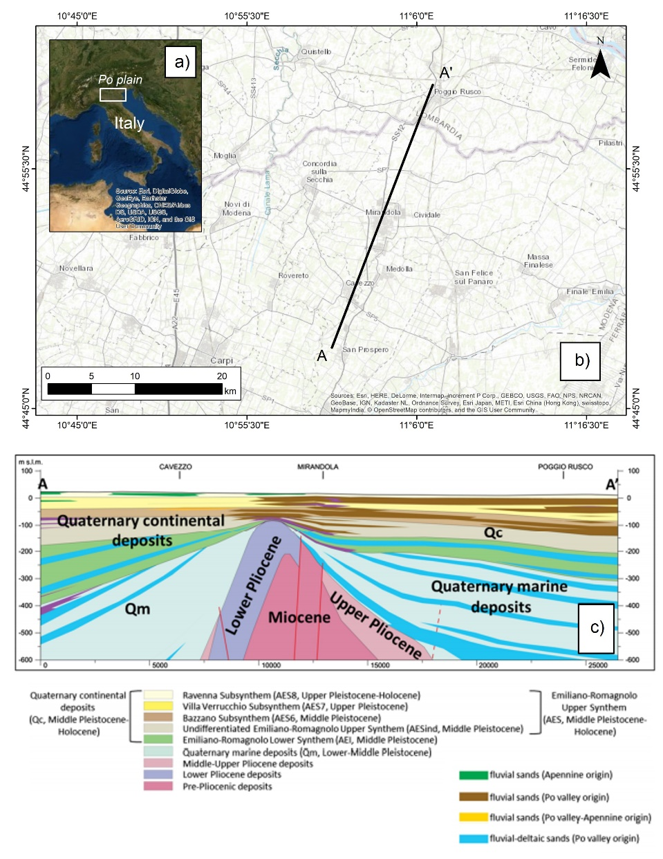

Figure 1. a) Geographical location of the study area. b) Localization of the geological cross section. c) Geological section AA’ (modified from Paolucci et al., 2015).

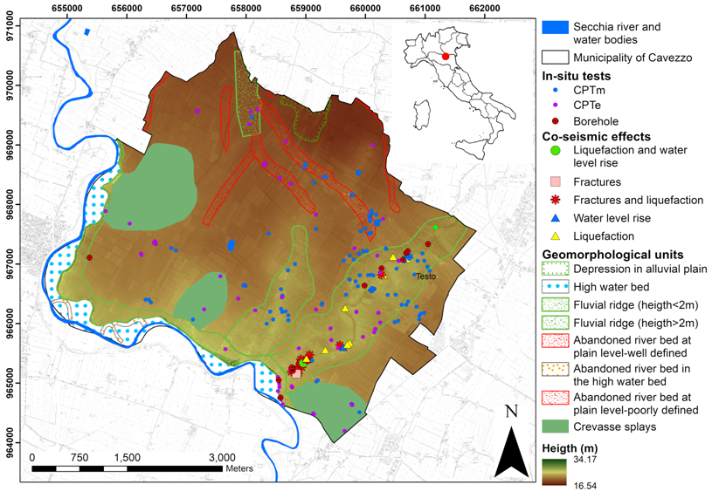

Figure 2. Main geological and geomorphological features of the area of Cavezzo (modified from Meisina et al., 2019).

- 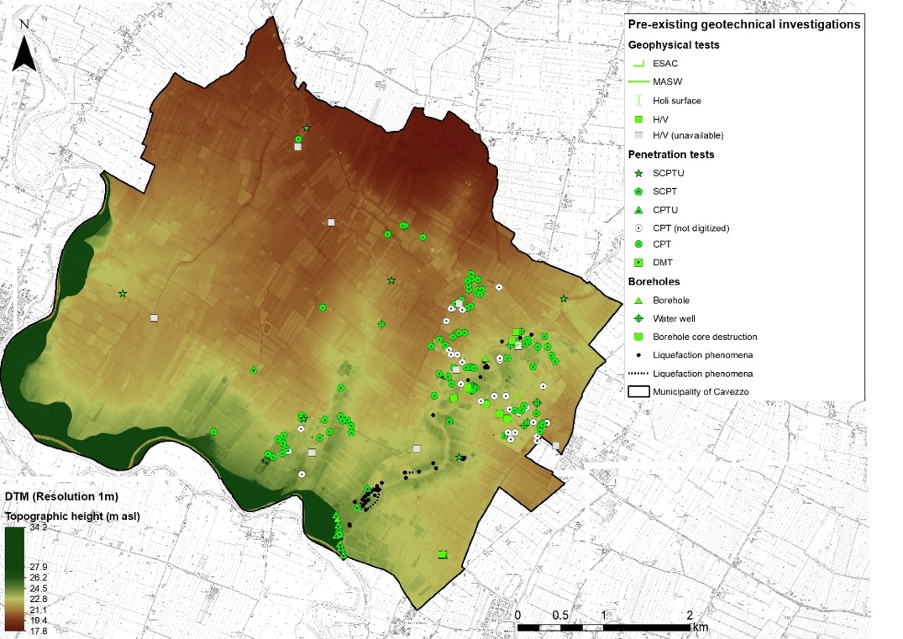

- 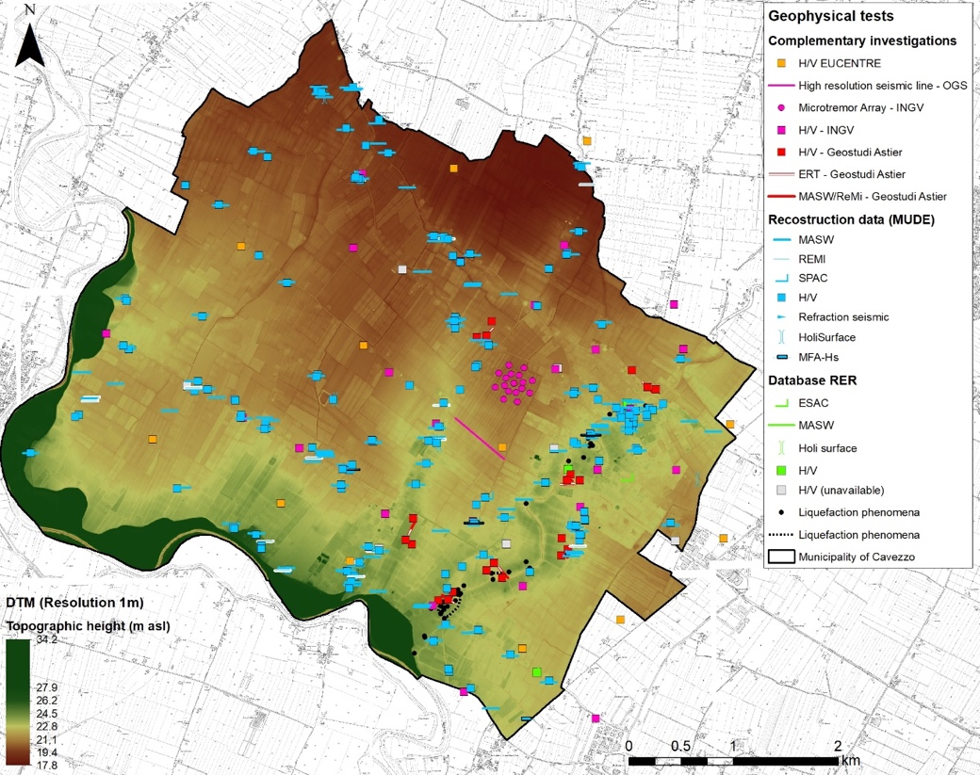

- 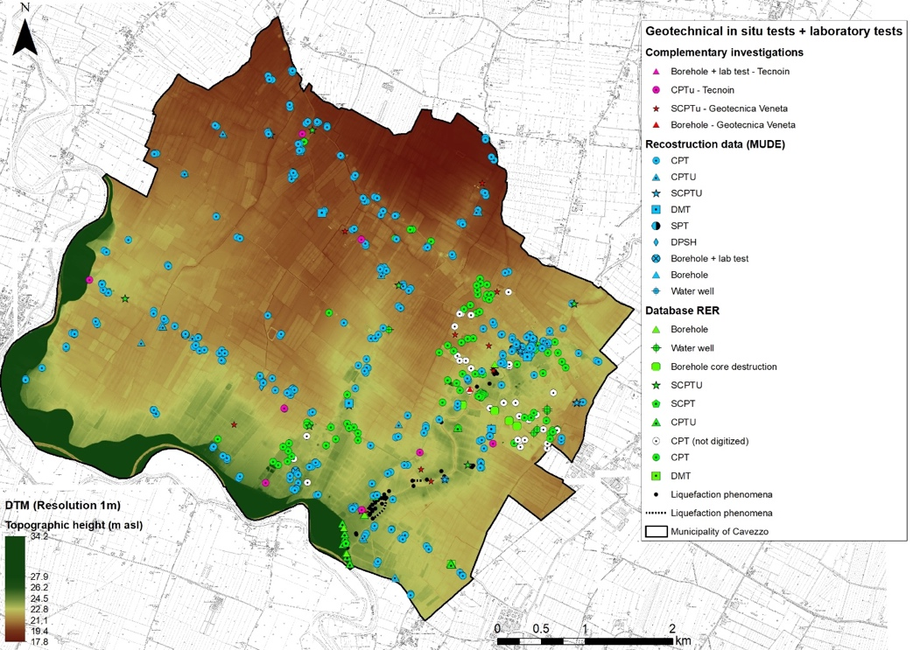

Figure 3. Location of the previously available (a) and newly acquired geophysical (b) and geotechnical (c) analyses performed on the study area. The manifestations of soil liquefaction occurred in 2012 sequence (black dots) and 1m resolution digital elevation model are superimposed. Modified from Lai et al. (2019).

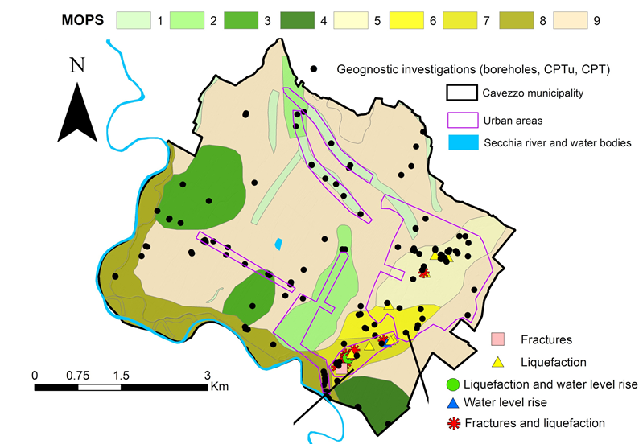

Figure 4. Map of 9 homogenous geological zones (MOPS) defined for Cavezzo municipality. Modified from Meisina et al. (2019), which we refer for a detailed description of the zonation process.

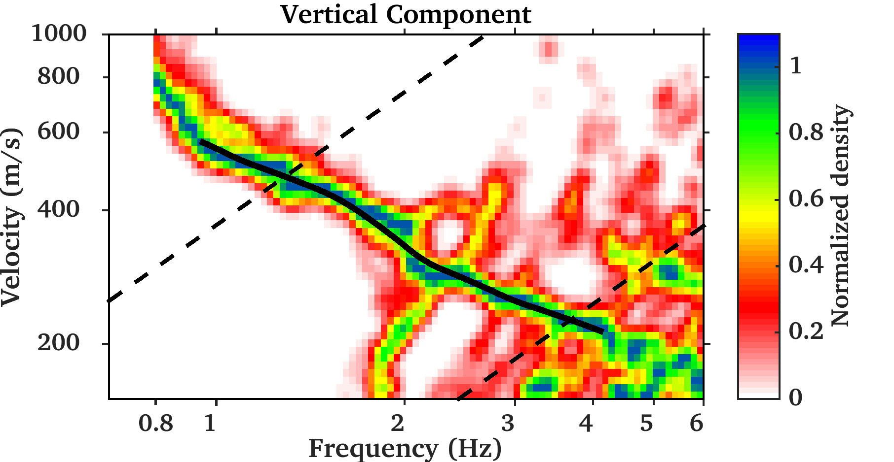
(a)
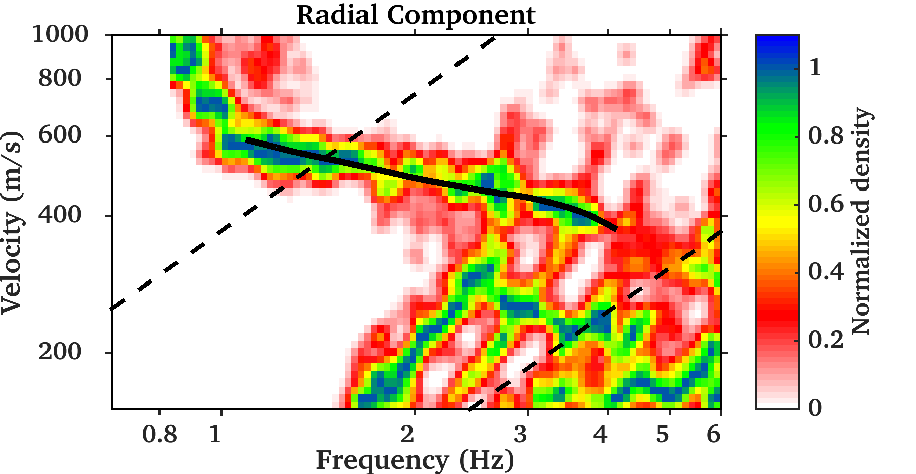
(b)
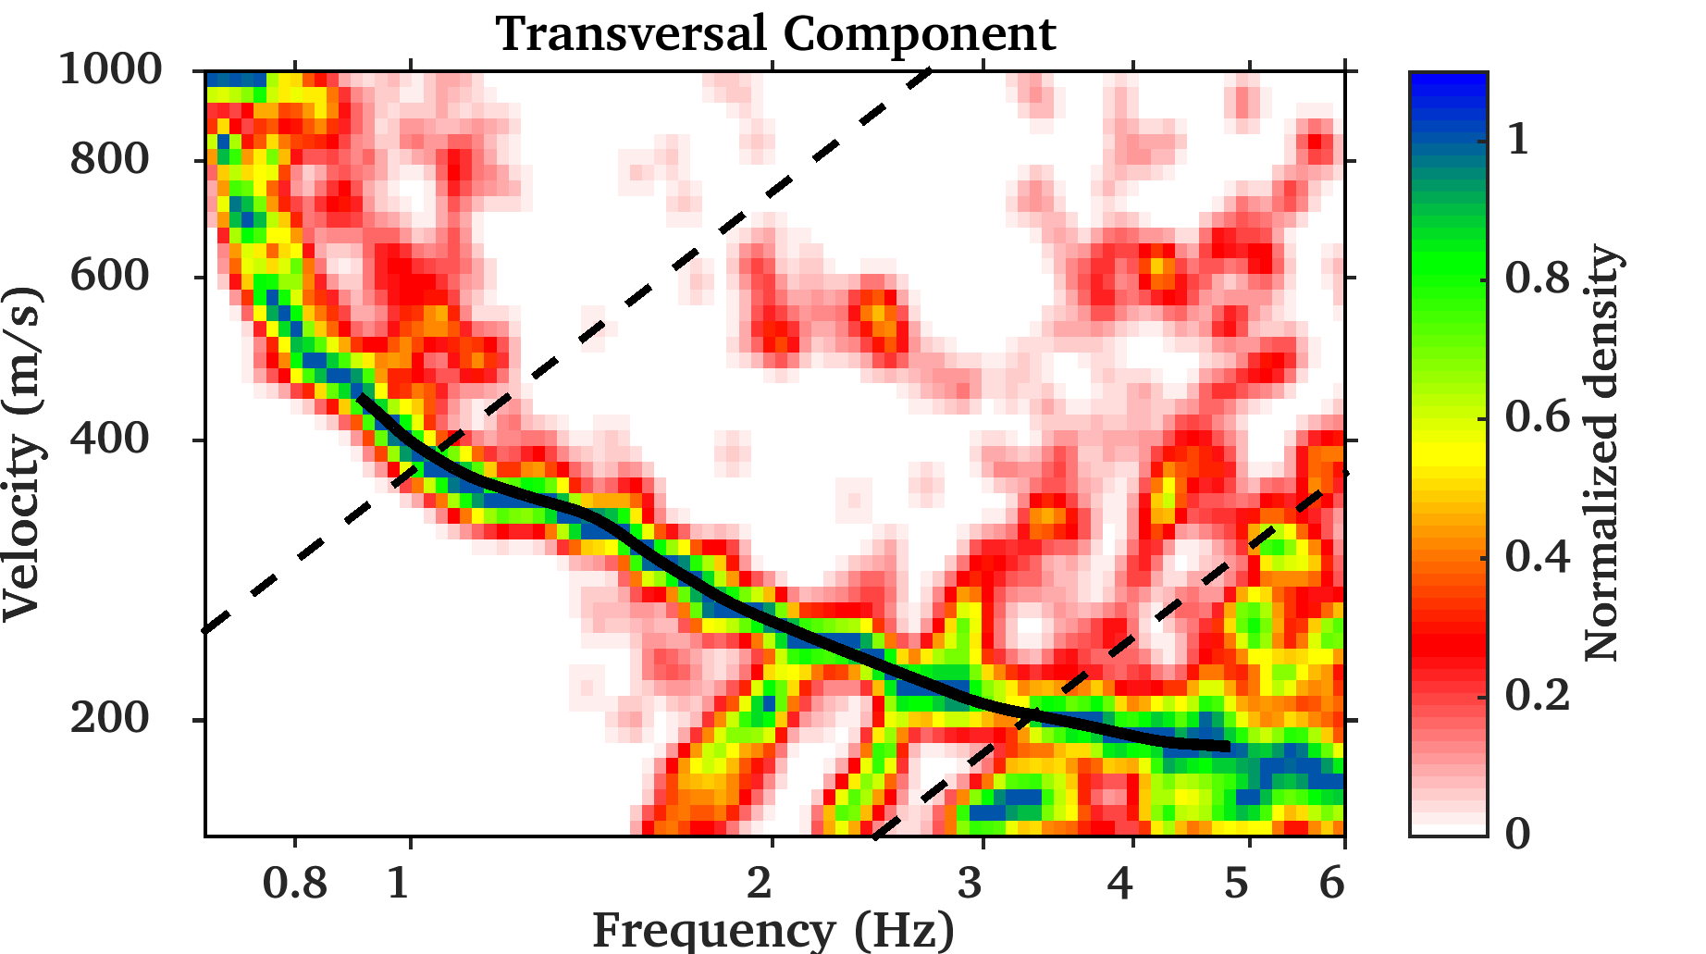
(c)

Figure 5. Retrieved Rayleigh (vertical and radial motion) and Love (transversal motion) dispersion curves (in black) obtained from three-component f-k analysis of ambient vibration array data using the approach described in Poggi & Fäh. (2010). Dashed lines are the min.-max. resolution limits of the investigated 2D seismic array.

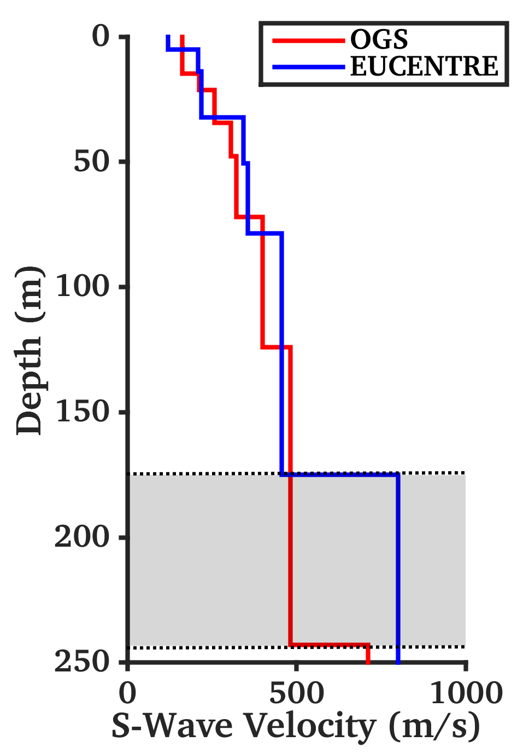

Figure 6. Comparison between two sample models from surface wave inversion of ambient vibration data (EUCENTRE) and from high-resolution P/S seismic reflection survey (OGS). The models show an overall good match down to a depth of about 170m, but with different interpretations of the seismic bedrock location and velocity. Since the two models match equally well observations, the grey area is therefore considered as epistemic uncertainty of the performed analyses. where an interface assumed to represent the seismic bedrock is located. Velocity is progressively mismatching for the deeper layers.

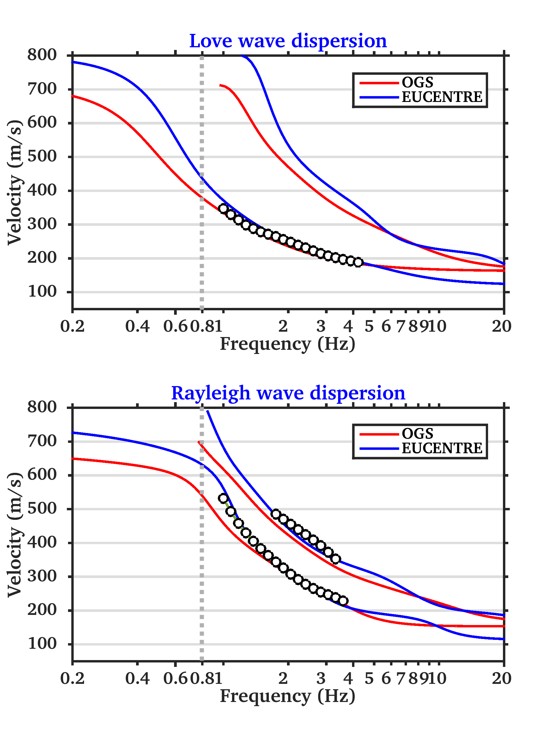
Figure 7. Comparison between Love and Rayleigh dispersion curves from three-component f-k analysis of ambient vibration array data (black dots) and the modelled results of the EUCENTRE and OGS. The former model was further constrained by the use of Rayleigh ellipticity and the fundamental frequency of resonance of the site (f₀, dashed grey line), as described more in detail in the text.

a)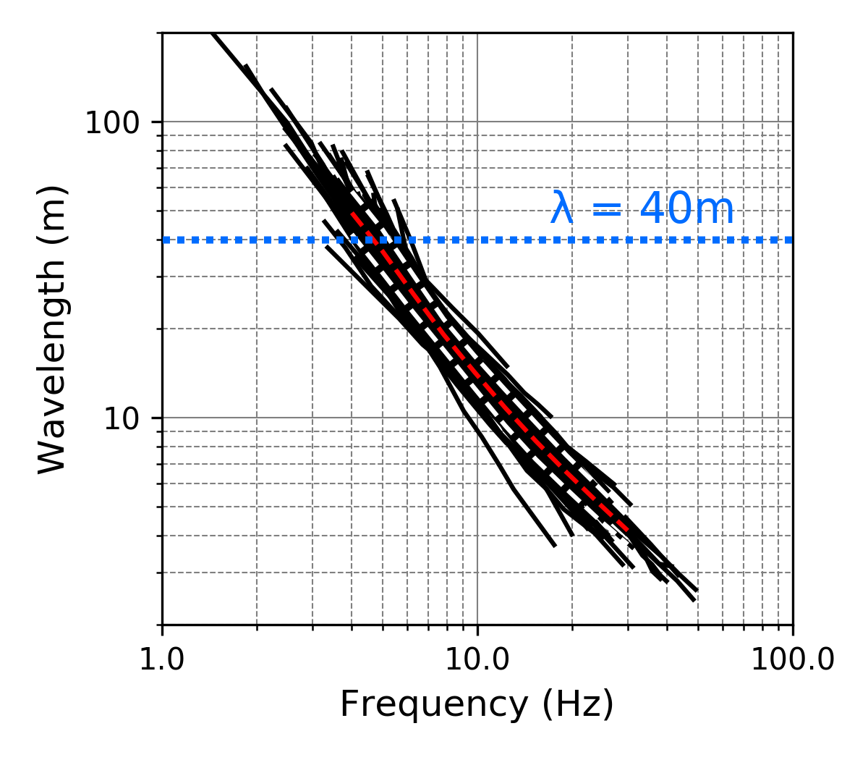
b) 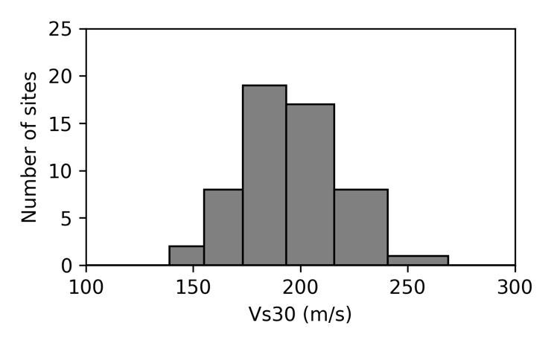

Figure 8. (a) Rayleigh wave dispersion curves form MASW analysis available for the territory (in black). Mean (red dots) and standard deviation (white dots) of the distribution is also presented to show the overall variability. (B) Distribution of the V_{S30} values obtained from the λ_{40m} empirical approximation.

(a)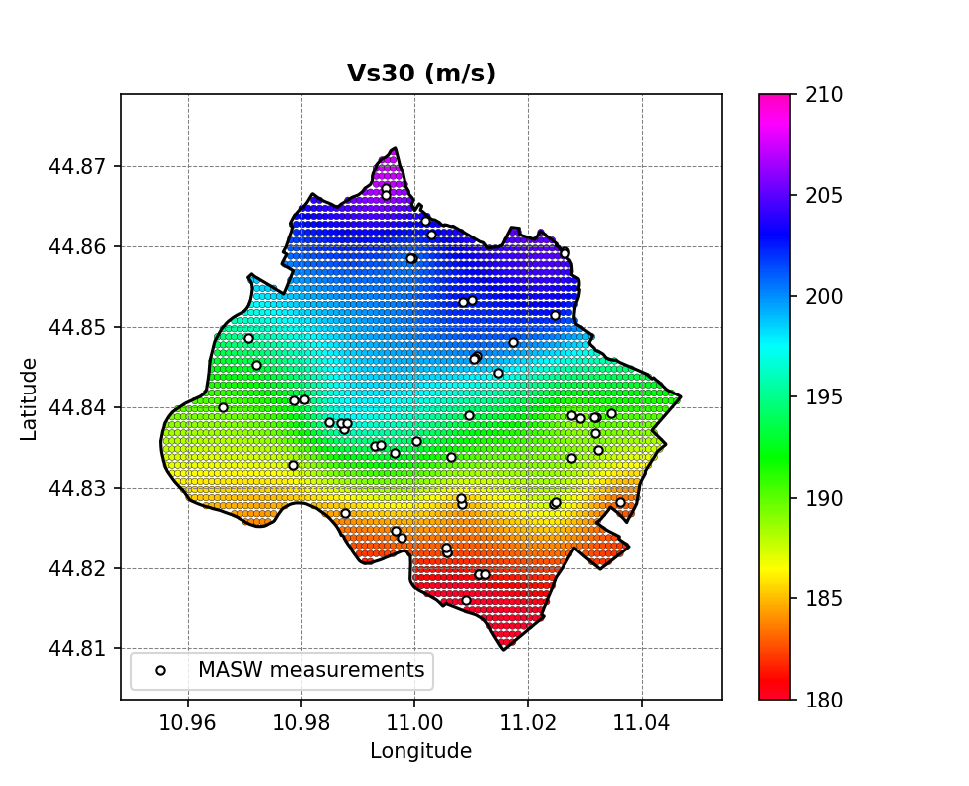
(b)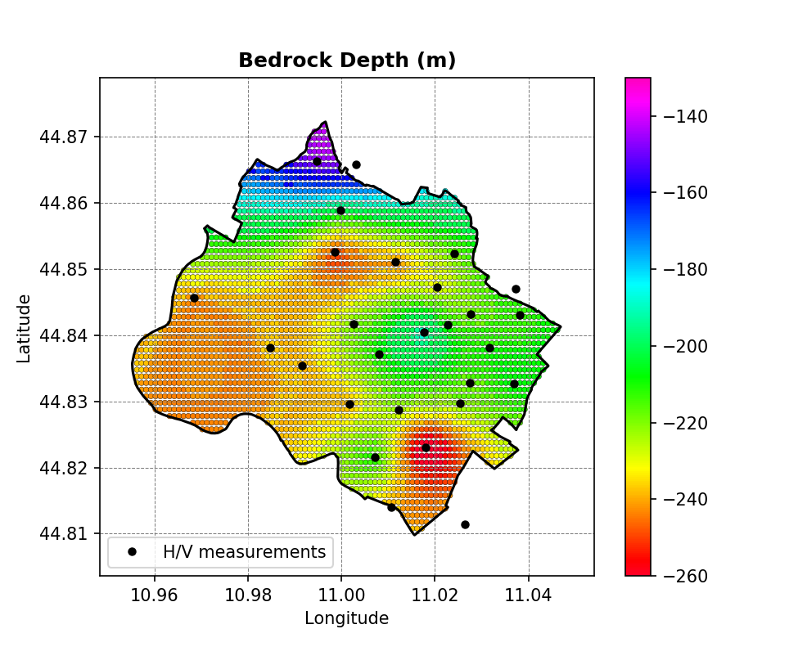

Figure 9: Maps of the Vs30 distribution compute from the actual 1D velocity profiles (a) and seismic bedrock depth (b) of the pseudo-3D model developed for Cavezzo. Location of the active (MASW) and passive (single station H/V) tests is superposed to highlight the spatial distribution of the model constraints.

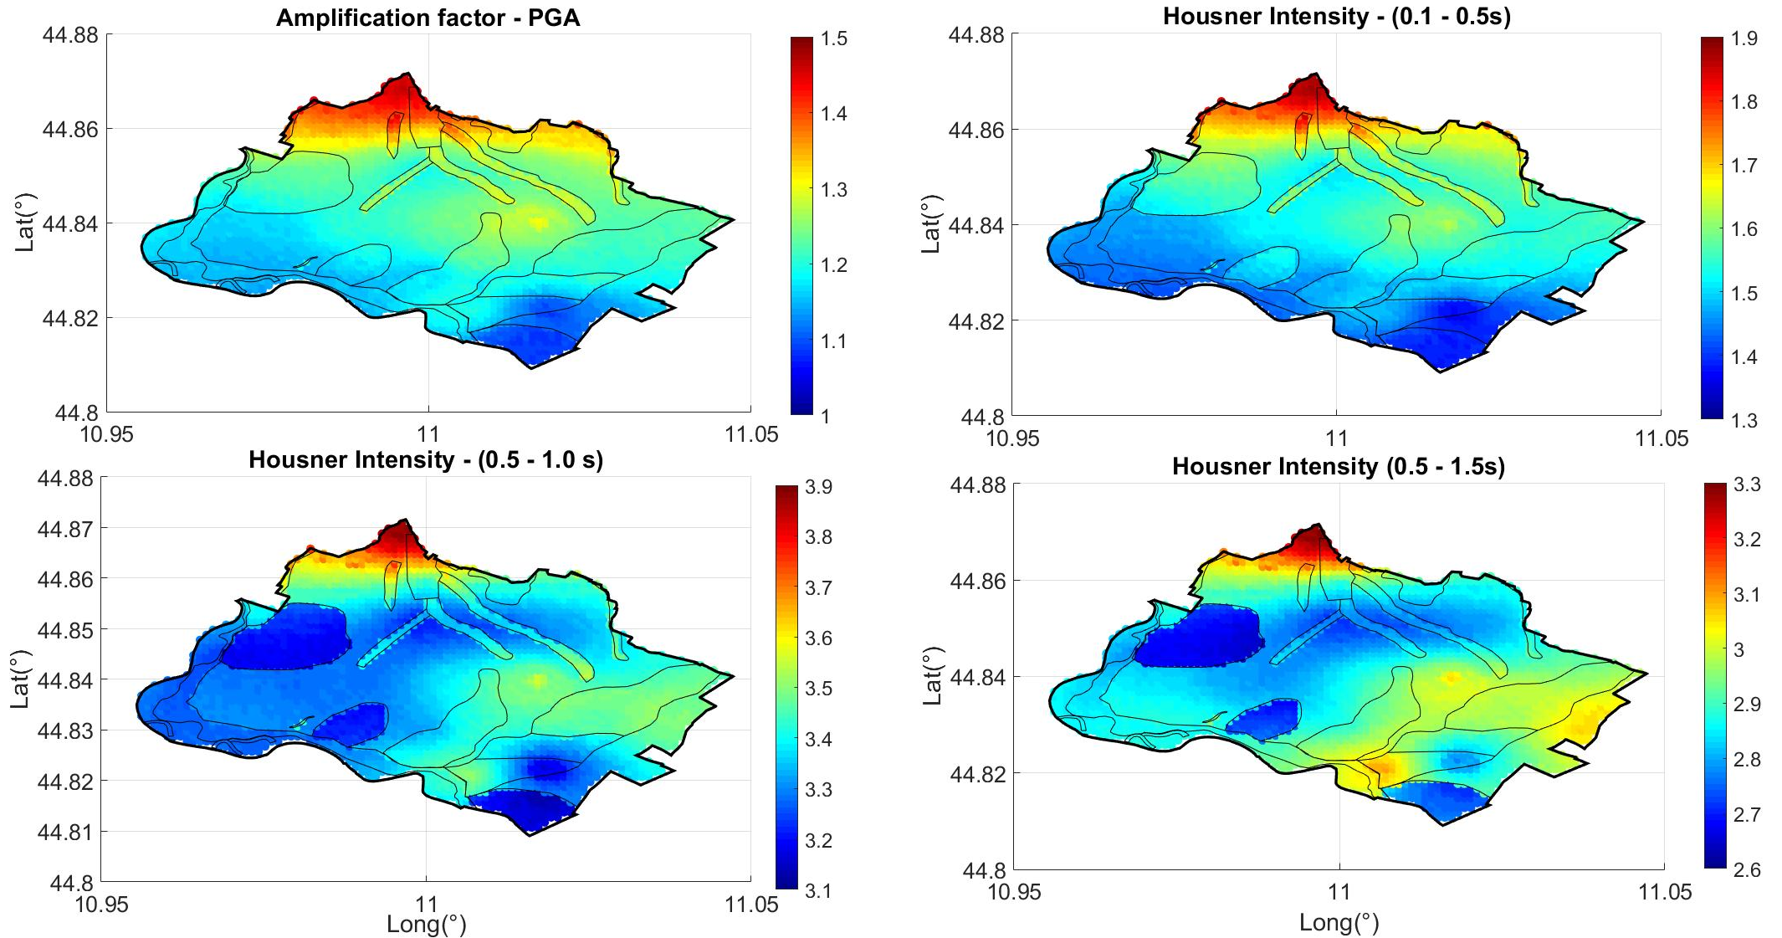

Figure 10. Map of amplification factors computed for Cavezzo considering the 475-years return period. Top left: PGA; Top right: Housner intensity ratio (0.1s≤T≤0.5s); Bottom left: Housner intensity ratio (0.5s≤T≤1.0s); Bottom right: Housner intensity ratio (0.5s≤T≤1.5s). The 9 homogenous geological zones (MOPS) defined for Cavezzo municipality are superimposed.

